**HO CHI MINH UNIVERSITY OF TECHNOLOGY AND EDUCATION**

**FACULTY OF HIGH QUALITY TRAINING**



**Final Report**

**Artificial Intelligence**

**Lecturer: PhD. Tran Nhat Quang**

**Class: ARIN330585E_22_1_02CLC**

**Subject ID: 221ARIN330585E**

**Members:**

Vo Minh Hung – 20110426

Nguyen Thanh Sang – 20110393

Nguyen Trung Nguyen – 20110388

Hoang Le Tien Dat – 20110011

***Thu Duc city, December, 2022***

**Contents**

TASK ASSIGNMENT 6

CHAPTER 1: INTRODUCTION TO AI 9

**1.1. Why should we learn Artificial Intelligence? 9**

**1.2. What programming language and technologies that people use nowadays? 10**

**1.3. What is Artificial Intelligence 11**

**1.4. Where is AI Technology Being Applied? 12**

**1.5. Human vs AI 14**

**1.5.1. Garry Kasparov vs Deepblue 14**

**1.5.2. Waston vs Ken 14**

**1.5.3. AlphaStar vs MaNa 15**

**1.6. How far can they go? 16**

**1.7. What is Intelligence? 16**

**1.8. What is Artificial? 16**

CHAPTER 2: PYTHON 16

CHAPTER 3: PYTHON (CONTINUE) 16

CHAPTER 4: ETHICS AND LAWS FOR AI 16

**4.1. Three approaches in normative ethics: 16**

**4.1.1. Virtue ethics: 16**

**4.1.2. Deontology: 17**

**4.1.3. Consequentialism: 17**

**4.1.4. Golden Rules 17**

**4.2 Fundamental ideas and concepts 22**

**4.2.1. History of AI 22**

**4.2.2. Four approaches to AI 22**

**4.2.3. Foundation of AI 23**

**4.2.4. Basic concepts of AI 23**

**4.2.5. Reward system 24**

CHAPTER 5: FUNDAMENTAL CONCEPTS 24

**5.1. Exploit vs Explore 24**

**5.2. Environment 25**

**5.2.1. Fully observable, partially observable, and unobservable 25**

**5.2.2 Single-agent vs Multi-agent 25**

**5.2.3. Episodic vs Sequential 26**

**5.3. State presentation 26**

**5.4. Solving problem by searching 27**

**5.5. Searching for solution 28**

**5.5.1. Problem 28**

**5.5.2. Tree Search 29**

**5.5.3. Graph Search 30**

CHAPTER 6: UNINFORMED SEARCH: 30

**6.1. First method: Breadth–first search 30**

**6.2. Components of a node: A node will be a class and has 4 properties: 31**

**6.3. Three common variants of queues: 31**

**6.4. BFS Demo: 32**

**6.5. Uniform-cost search algorithm: 33**

**6.5. Difference of Uniform-cost-search from breath-first search: 33**

**6.6. DFS Demo: 33**

**6.7. Iterative deepening search 35**

**6.8. Depth-limited search (TREE-SEARCH version) 35**

CHAPTER 7. INFORMED SEARCH: 36

**7.1. Uniformed vs Informed strategy: 36**

**7.2. Evaluation function f(n): 36**

**7.3. Best-first search: 36**

**7.4. A* search demo: 38**

CHAPTER 8: GENERATING HEURISTIC FUNCTIONS 40

**8.1. Method 1: 40**

**8.2. Method 2: 40**

CHAPTER 9: LOCAL SEARCH: 41

**9.1. Local search – searching for goal states: 41**

**9.2. Problem: 42**

**9.3. How it works: 42**

**9.4. To overcome local optimal 43**

**1. Method 1: 43**

**2. Method 2: 43**

**3. Method 3: 43**

CHAPTER 9: AND-OR SEARCH 45

**9.1. SEARCHING IN NONDETERMINISTIC ENVIRONMENTS 45**

**9.1.1. The vacuum world 45**

**9.1.2. And-or search tree 46**

**9.2. SEARCHING IN PARTIALLY OBSERVABLE ENVIRONMENTS 47**

**9.2.1. Searching with no observation 47**

**9.2.2. Searching in partially observable problems 48**

CHAPTER 10: ONLINE SEARCH 51

**10.1. GENERAL 51**

**10.1.1. Use, competitive ratio, and dead-end states 51**

**10.1.2. Online depth-first search agent 52**

**10.2. ONLINE SEARCH ALGORITHMS (ONLINE A*) 52**

**10.2.1. Idea 52**

**10.2.2. Algorithm 53**

CHAPTER 11: Constraint Satisfaction Problems 53

**11.1. Definition 53**

**11.2. Constraint Propagation: Inference in CSPs 54**

**11.2.1. Constraint propagation 54**

**11.2.2. Local Consistency 54**

**11.3. Node consistency 55**

**11.4. Arc consistency 56**

**11.5. AC-3 Algorithm 56**

**11.6. Path Consistency 57**

**11.7. K-consistency: 58**

**11.8. Global constraint: 58**

**11.9. Sudoku problem: 58**

CHAPTER 12: BACKTRACKING SEARCH FOR CSPS: 59

**12.1. Ideas of backtracking search: 59**

**12.2. Setting: 61**

**12.2.1. Select next variable and value 61**

**12.2.2. Inference: 61**

**12.2.3. Backtrack strategies: 62**

CHAPTER 13: CAL SEARCH FOR CSPS: 62

**13.1. Ideas: 62**

FINAL PROJECT 64

**1. Introduction: 64**

**2. Analysis: 64**

**2.1. Algorithm: 64**

**2.2. Code: 64**

**2.2.1. Libraries: 64**

**2.2.2. Setting: 64**

**2.2.3. Function: 65**

REFERENCES 73

# TASK ASSIGNMENT

|  |  |  |
| --- | --- | --- |
| **Student’s name** | **Evaluate contribution** | **Taskwork** |
| Hoàng Lê Tiến Đạt | 100% | Making content from Chapter 1, Chapter 4,5 |
| Nguyễn Trung Nguyên | 100% | Making content from Chapter 6,7,8 |
| Võ Minh Hưng | 100% | Making Content from Chapter 9,10 |
| Nguyễn Thanh Sang | 100% | Making content from Chapter 11,12 |

**Note:** %: The percentage of each student participating.

|  |  |  |  |  |  |  |  |  |  |
| --- | --- | --- | --- | --- | --- | --- | --- | --- | --- |
| **No** | **Goal** | | **Schedule** | | | | | | |
| 1 | Understand & describe the requirements of the project. | | o | o |  |  |  |  |  |
| 2 | Learn & study technology, and language programming to do project | | o | o | o |  |  |  |  |
| 3 | Identify the functions and algorithm to be used in the report. | | o | o | o |  |  | o |  |
| 4 | Building & design report  architecture. | | o | o | o |  |  |  |  |
| 5 | Building & design content of report  architecture. | |  |  | o | o | o |  |  |
| 6 | Testing the report. | |  |  |  |  | o | o | o |
| 7 | Update and comment the report. | |  |  |  |  | o | o | o |
| Week | | | 2 | 4 | 6 | 8 | 10 | 12 | 14 |
| Note | | o-Begin | | O – Complete 50% | | | O – Complete 100% | | |

**Remark of teacher:**

..............................................................................................................................................................................................................................................................................................................................................................................................................................................................................................................................................................................................................................................................................................................................................................................................................................................................................................................................................................................................................................................................................................................................................................

|  |
| --- |
| Thu Duc city, December 2022 |
| **Signature and full name of teacher** |

# CHAPTER 1: INTRODUCTION TO AI

## Why should we learn Artificial Intelligence?

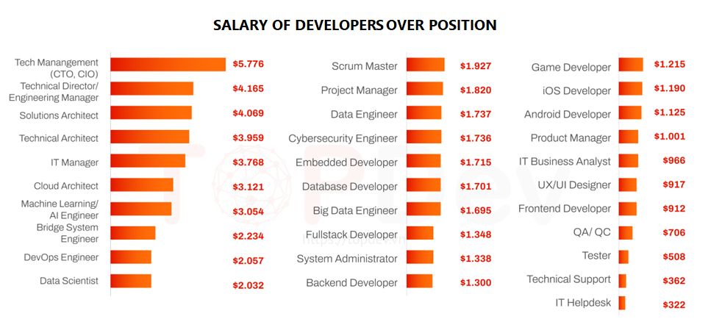

We should learn AI because of these reasons:

* First, AI applications are already having a huge impact on virtually every industry, and they’re also likely to continue growing in importance as new applications and technological solutions are created.
* Second, the AI industry is growing rapidly, with the International Data Corporation (IDC) projecting that the AI market, “including software, hardware, and services, is forecast to grow 16.4% year over year in 2021 to $327.5 billion.”
* Finally, jobs in the AI industry tend to pay excellent salaries, with data from the U.S. Census Bureau showing that the average salary for AI professionals is $102,521.

Some of the top positions for AI experts that offer an excellent average annual income include:

* AI Engineer/Scientist / 2018 Median Pay: $99,998
* Software Developer / 2020 Median Pay: $110,140
* Computer and Information Research Scientists / 2020 Median Pay: $126,830

## What programming language and technologies that people use nowadays?

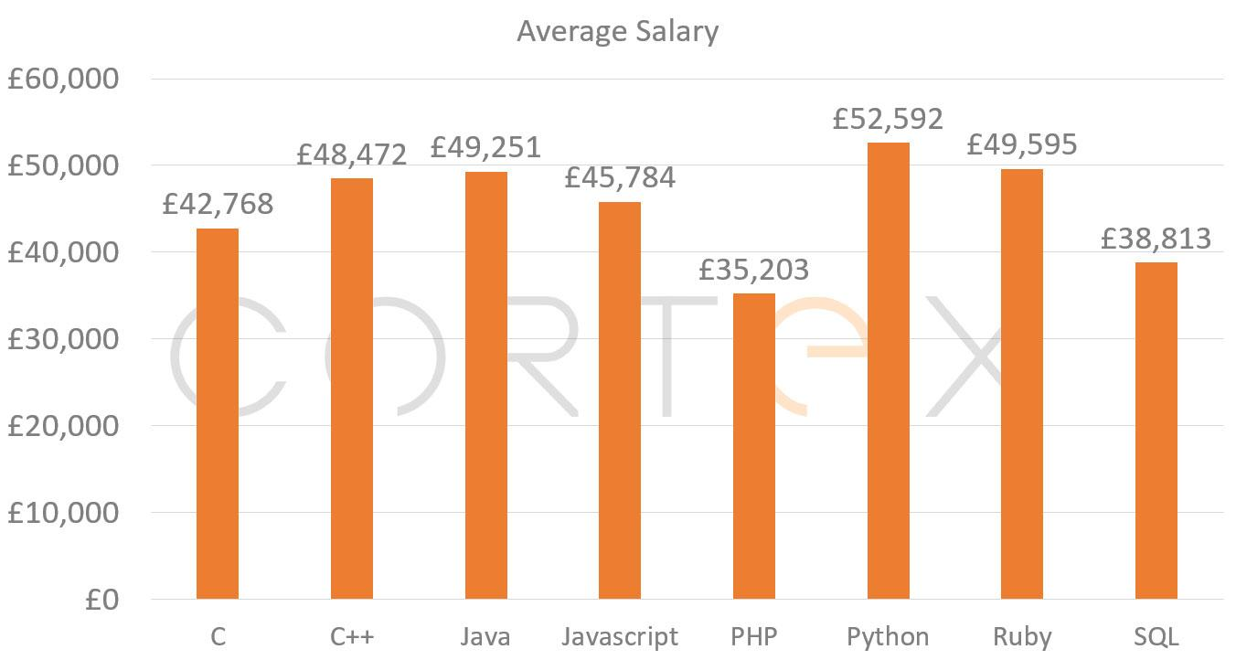

Python and Java are most in-demand and 2 of the highest paying programming salaries.

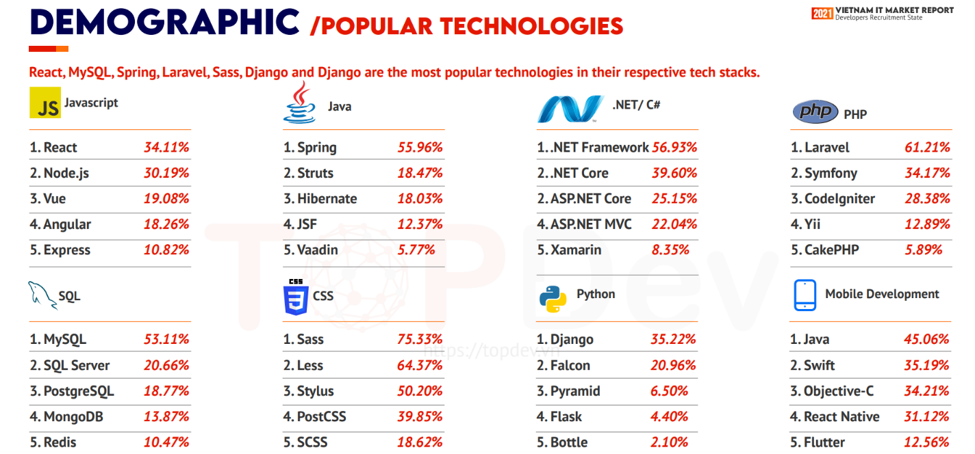

JavaScript is the most popular language together with other IT skills. In which, React, Nodejs & Vue are the top 3 choice of Javascript frameworks, while React & Node.js quite share the same popularity among developers. Top choice to work with Java is Spring (more than 55%) then Struts & Hibernate respectively. There hasn't been much change in .NET/C# list in which .NET Framework, .NET Core & ASP.NET Core top the list. Laravel remains the most popular framework in the PHP tech stack with more than 61%, followed by Symfony (34.17%) & CodeIgniter (28.38%). MySQL keeps leading the SQL tech stack with more than 53%. However, the level popularity among SQL systems doesn't vary that much while Top 5 (MySQL, SQL Server, PostgreSQL, MongoDB & Redis) contribute respectively the same importance of database functions in every development. Top 5 CSS preprocessors places belong to Sass, Less, Stylus, PostCSS & SCSS. Python - one of the hottest ‘player’ recently in technologies world - show significant gap in popularity among choices, in which Django framework choice accounts for 35.22% while the 5th rank (Bottle) just share 2.1%. Among Mobile Developers, Java, Swift & Objective-C take the places on top 3 list of programing languages choice. Meanwhile, new "players" - React Native and Flutter have experienced dramatic increase in popularity in recent years

## What is Artificial Intelligence

AI is a technology that mimics human intelligence, allowing computer applications to learn from experience via iterative processing and algorithmic training.

AI systems get smarter with each successful round of data processing since each interaction allows the system to test and measure solutions, and develop expertise in the task it’s been set to accomplish.

Since this can be completed rapidly, much faster than the rate a human being would be able to perform similar work, AI systems can become experts far faster than humans, making them incredibly effective options for any process requiring intelligent decision-making.

This makes AI an incredibly powerful, and extremely valuable technology, since it essentially allows computers to think and behave like humans, but at much faster speeds and with much more processing power than the human brain can produce.

In many cases and for a variety of different applications, AI systems are capable of significantly outperforming humans, and that’s the primary reason why AI technology has become so important to the modern economy.

## Where is AI Technology Being Applied?

Here’s just a handful of specific applications where artificial intelligence has proven to be incredibly effective:

Healthcare - AI applications are being used to deliver personalized medicine, providing patients with reminders about when to take their medicine, and suggestions about which specific exercises they should perform.

Retail - AI technology is applied in retail environments to handle stock management, design more effective store layouts, and provide personalized shopping recommendations via Amazon’s “You May Also Like” suggestions, as well as personalized viewing suggestions via Netflix’s machine learning-driven recommendation algorithm.

Manufacturing - AI solutions are used to forecast load and demand for factories, ensuring they’re run as efficiently as possible by helping to make better decisions about logistics and planning for materials ordering, timetables to project completion, etc.

Banking - AI systems are being used to review financial transactions to detect fraudulent activity, assess credit scores with greater accuracy, and automate tasks requiring manual data input and data management.

Life Sciences - AI technology is being applied to test new medicines, allowing organizations to bring them to market sooner, and to analyze large and complex data sets that help discover new, more effective therapies and pharmaceutical drugs.

Life Services – AI technology is also used for daily living services like translating and find information.



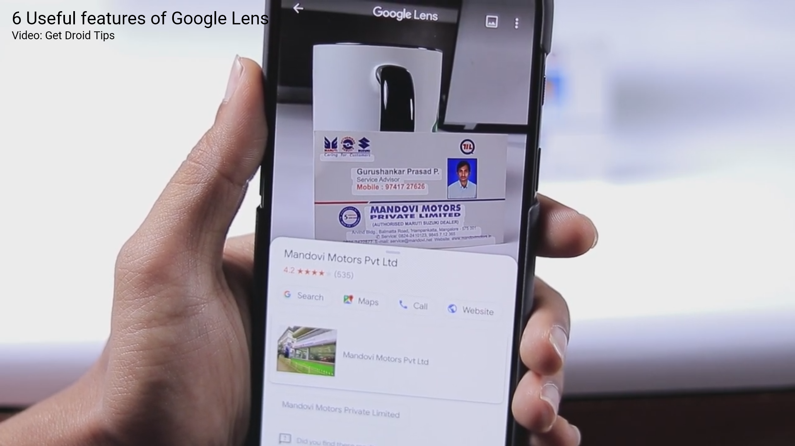

Clearly, AI has already been applied to a whole host of important processes, but there are hundreds or even thousands of additional applications for virtually every sector of the modern economy.

## Human vs AI

### Garry Kasparov vs Deepblue

On May 11, 1997, chess grandmaster Garry Kasparov resigns after 19 moves in a game against Deep Blue, a chess-playing computer developed by scientists at IBM. This was the sixth and final game of their match, which Kasparov lost two games to one, with three draws.

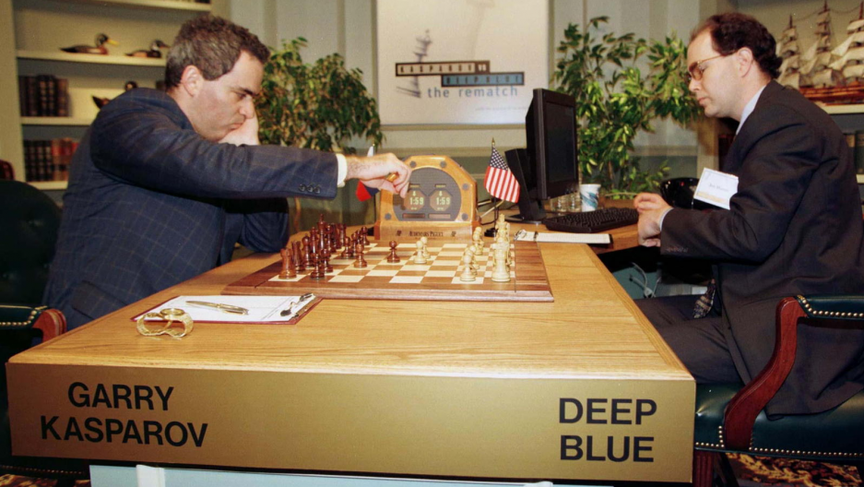

### Waston vs Ken

Jeopardy! champion Ken Jennings points to his IBM supercomputer opponent, Watson, during a practice round for the TV game show last month. Jennings and fellow human contestant Brad Rutter competed against Watson in a three-episode tournament this week in the U.S.—and were summarily beaten by the computer

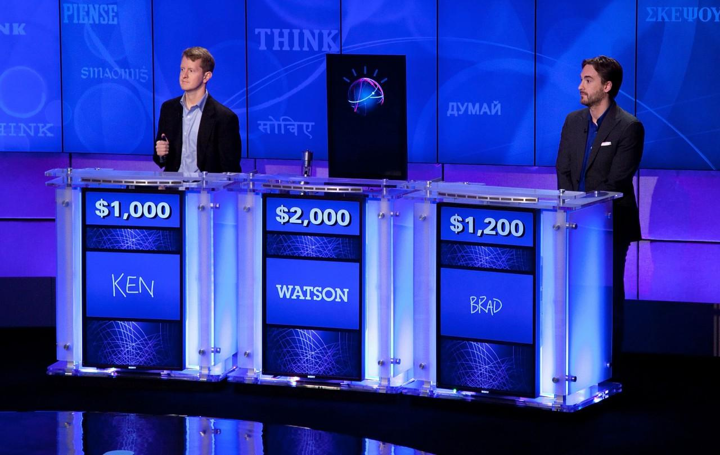

### AlphaStar vs MaNa

AlphaStar, DeepMind's StarCraft II playing AI, has finally been beaten by a human. Pro SCII champ Grzegorz "MaNa" Komincz prevailed in a live-streamed head-to-head match against a new version of the AI that more closely mimics a human player's "economy of attention." MaNa found a weakness and beat the AI for the first time.

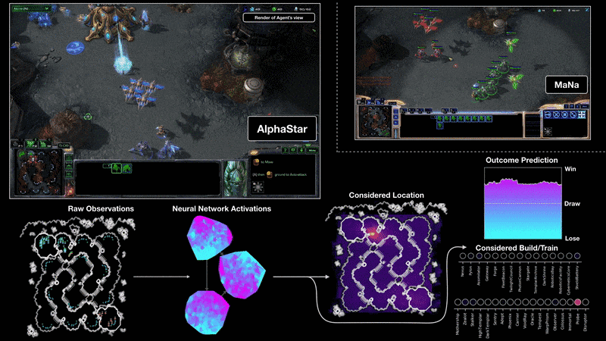

## How far can they go?

They can run 365 days a year, analyze data and learn. This redefines the term lifelong learning. Machine learning is far more effective than human learning. So we can say, there is no stopping point for them.

## What is Intelligence?

Intelligence is the ability of human beings (and to a lesser extent of some higher animals) to construct useful information to solve a problem, based on environmental conditions and what has been learned previously. In other words: intelligence is the ability to solve a problem using creativity, memory, and deductive ability.

## What is Artificial?

Artificial word is, made or produced by human beings rather than occurring naturally, especially as a copy of something natural.

When something is artificial, or man-made, it has been made by humans, not nature. For example, an artificial satellite is one made by humans, while a natural satellite is a satellite that was not made by humans. Many artificial things imitate or copy things found in nature.

# CHAPTER 2: PYTHON

# CHAPTER 3: PYTHON (CONTINUE)

# CHAPTER 4: ETHICS AND LAWS FOR AI

The story came after repeated warnings from many of the most respected minds in the world: people including Stephen Hawking have suggested that artificial intelligence could potentially bring about the end of humanity when they have a thing called awareness. Until this technology is fully developed, experiences will also make us learn how to limit them and not go overboard. So in the end it is just all about the waiting game.

## 4.1. Three approaches in normative ethics:

### 4.1.1. Virtue ethics:

Virtue ethics is a philosophy developed by Aristotle and other ancient Greeks. It is the quest to understand and live a life of moral character virtue ethics helps us understand what it means to be a virtuous human being. And, it gives us a guide for living life without giving us specific rules for resolving ethical dilemmas.

### 4.1.2. Deontology:

Deontology is an ethical theory that uses rules to distinguish right from wrong. Following the rules makes deontology easy to apply, but it also means disregarding the possible consequences of our actions when determining what is right and what is wrong.

### 4.1.3. Consequentialism:

Consequentialism is an ethical theory that judges whether or not something is right by what its consequences are. For instance, most people would agree that lying is wrong. But if telling a lie would help save a person’s life, consequentialism says it’s the right thing to do.

And to comply the consequentialism, we have golden rules.

### 4.1.4. Golden Rules

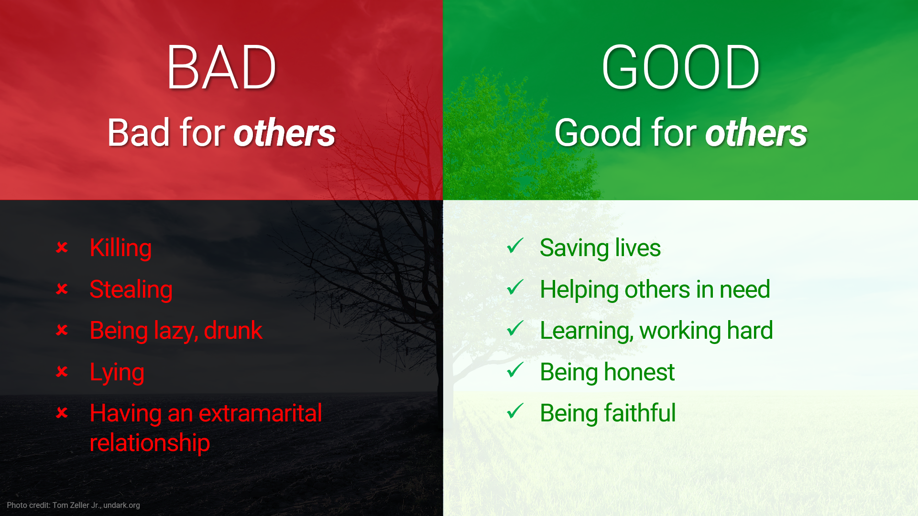

* An action is Good when it is good for others, and it is considered Bad when it is bad for others.

The Golden Rule expects us to be fair, honest, generous, kind, and all those things that are good according to ethical tradition. It expects us to empathize with others; to see things from another person’s point of view. It applies between two people, and groups, and between individuals and groups.

So Golden Rules have a drawback in that it only applies to others, not ourself.

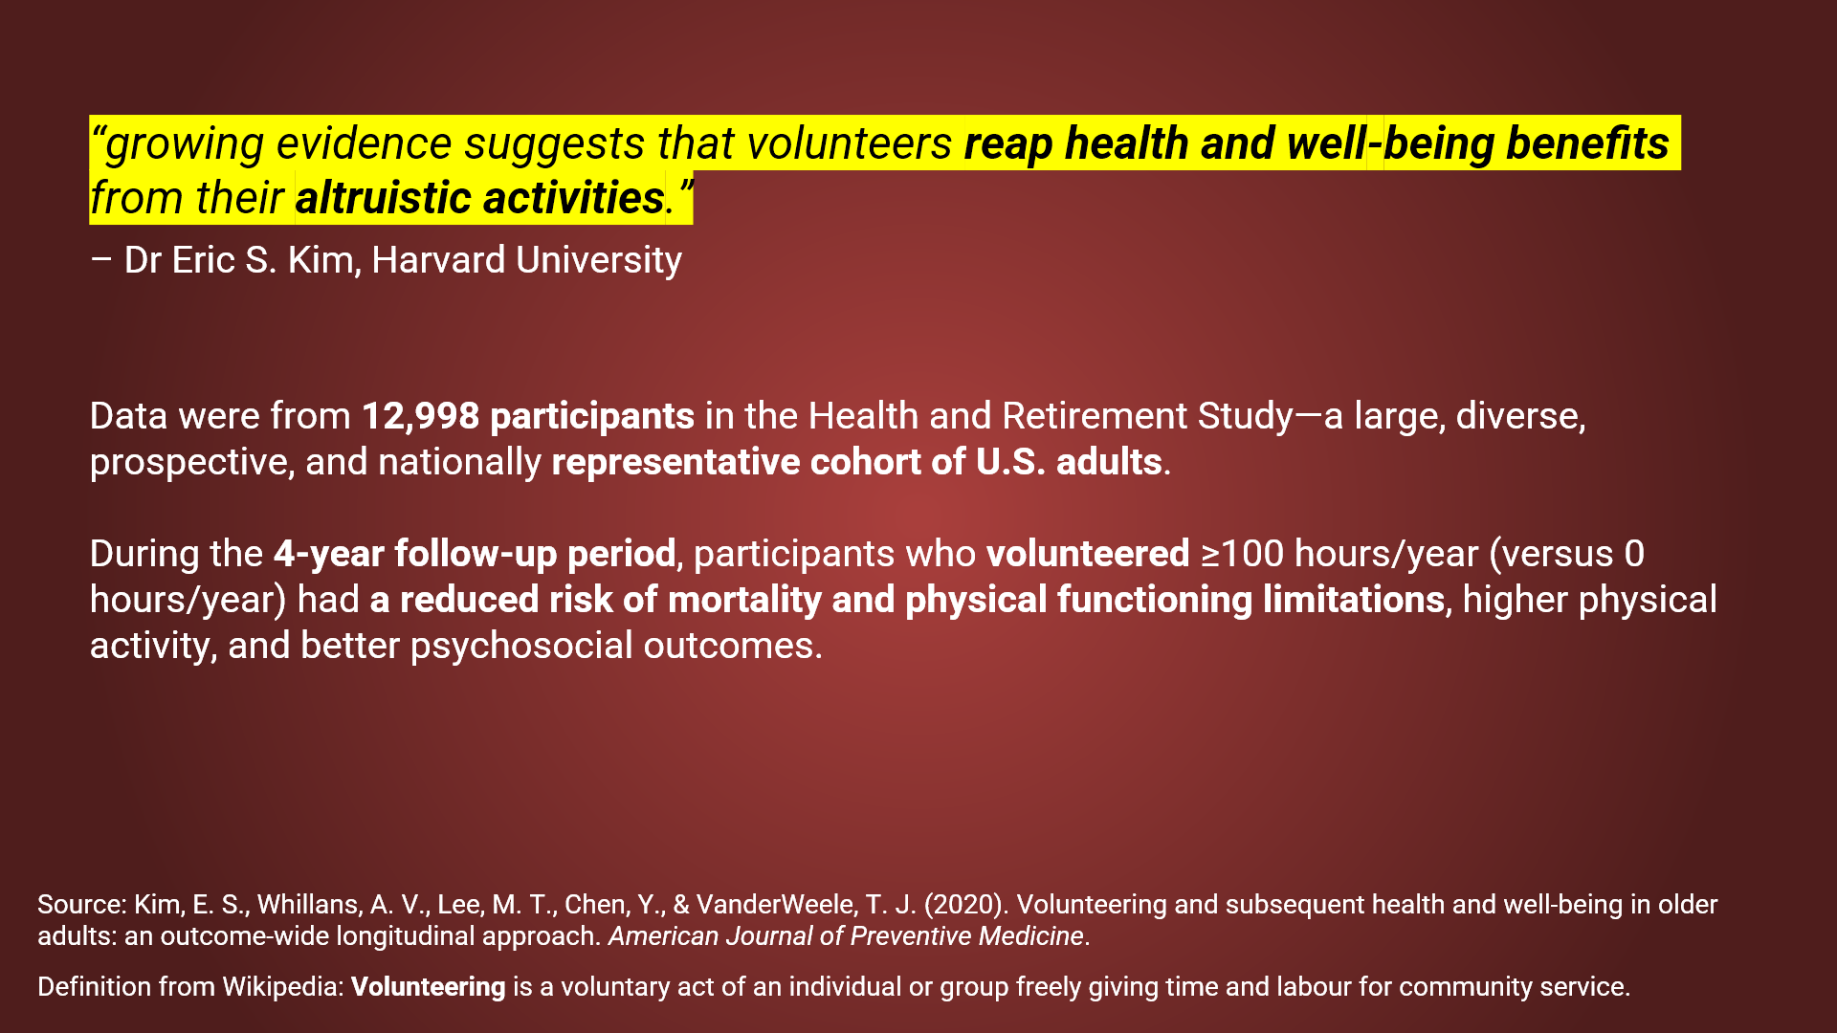

According to the Data Analysis, we can see that doing golden rules also gains some profit, for examples higher physical activity or better psychosocial outcomes. Also, when we look at Newton's third law or a famous proverb: What goes around, comes around.

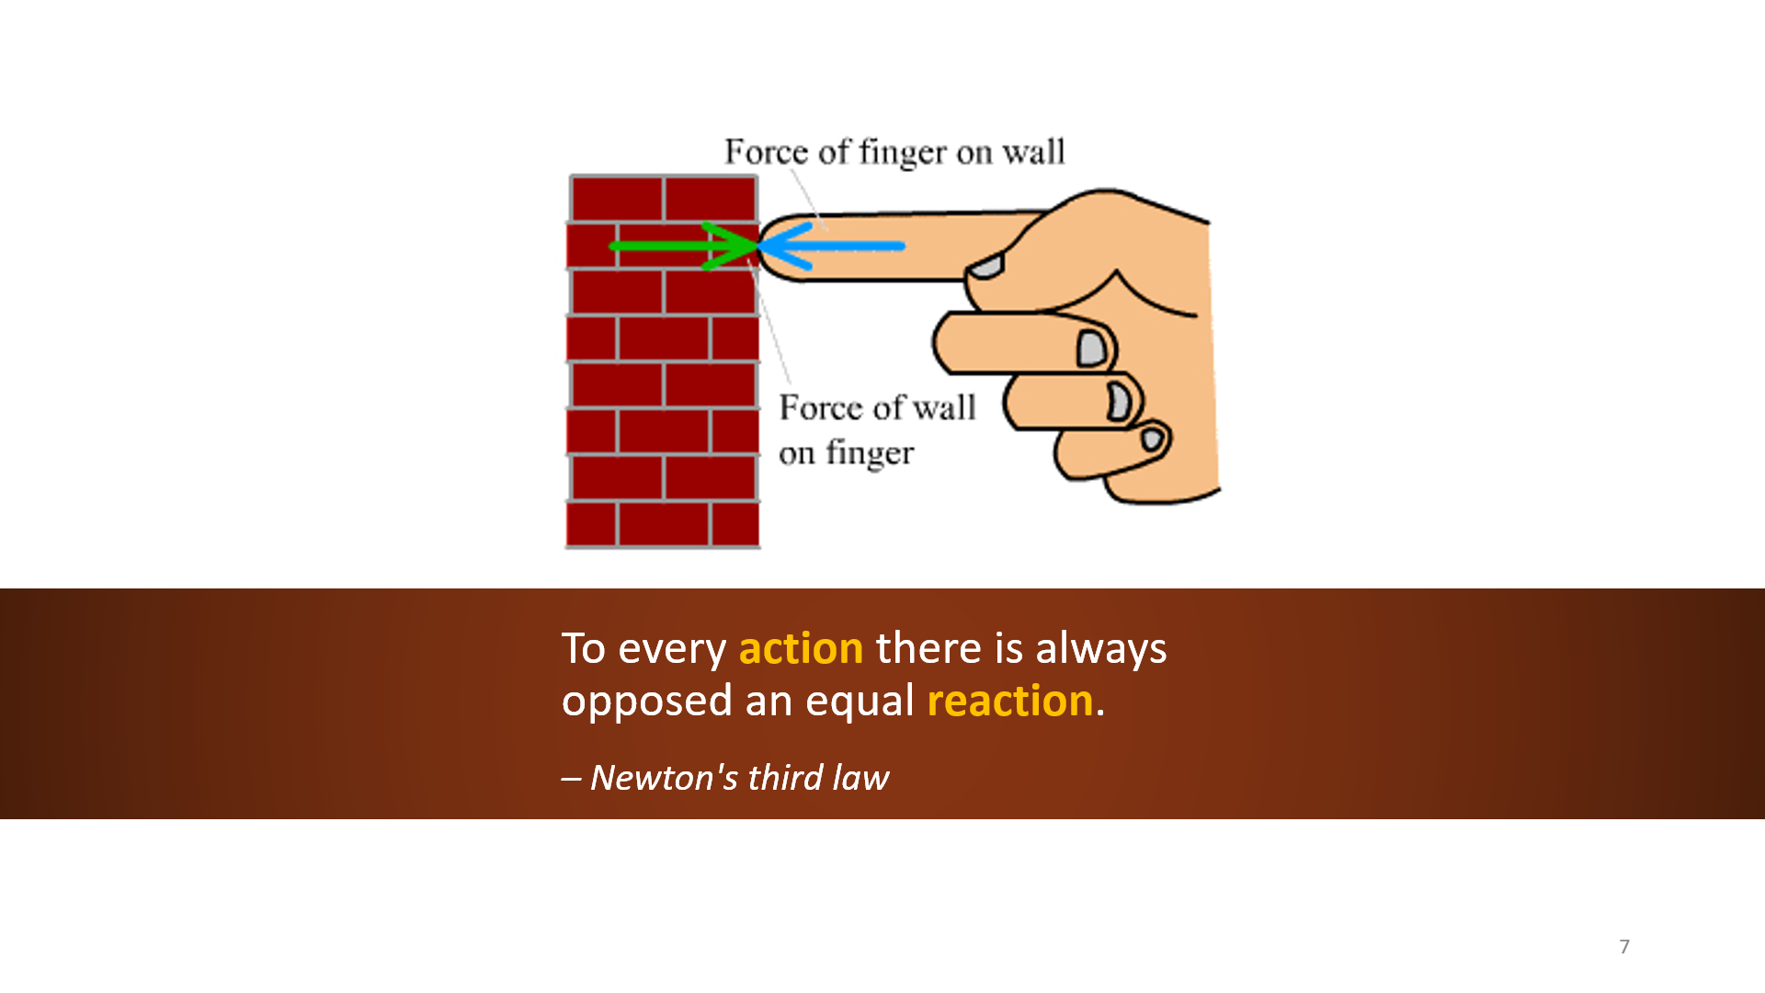

* So, to prevent human extinction when AI have awareness, they must have golden rules.

The table below applies golden rules:

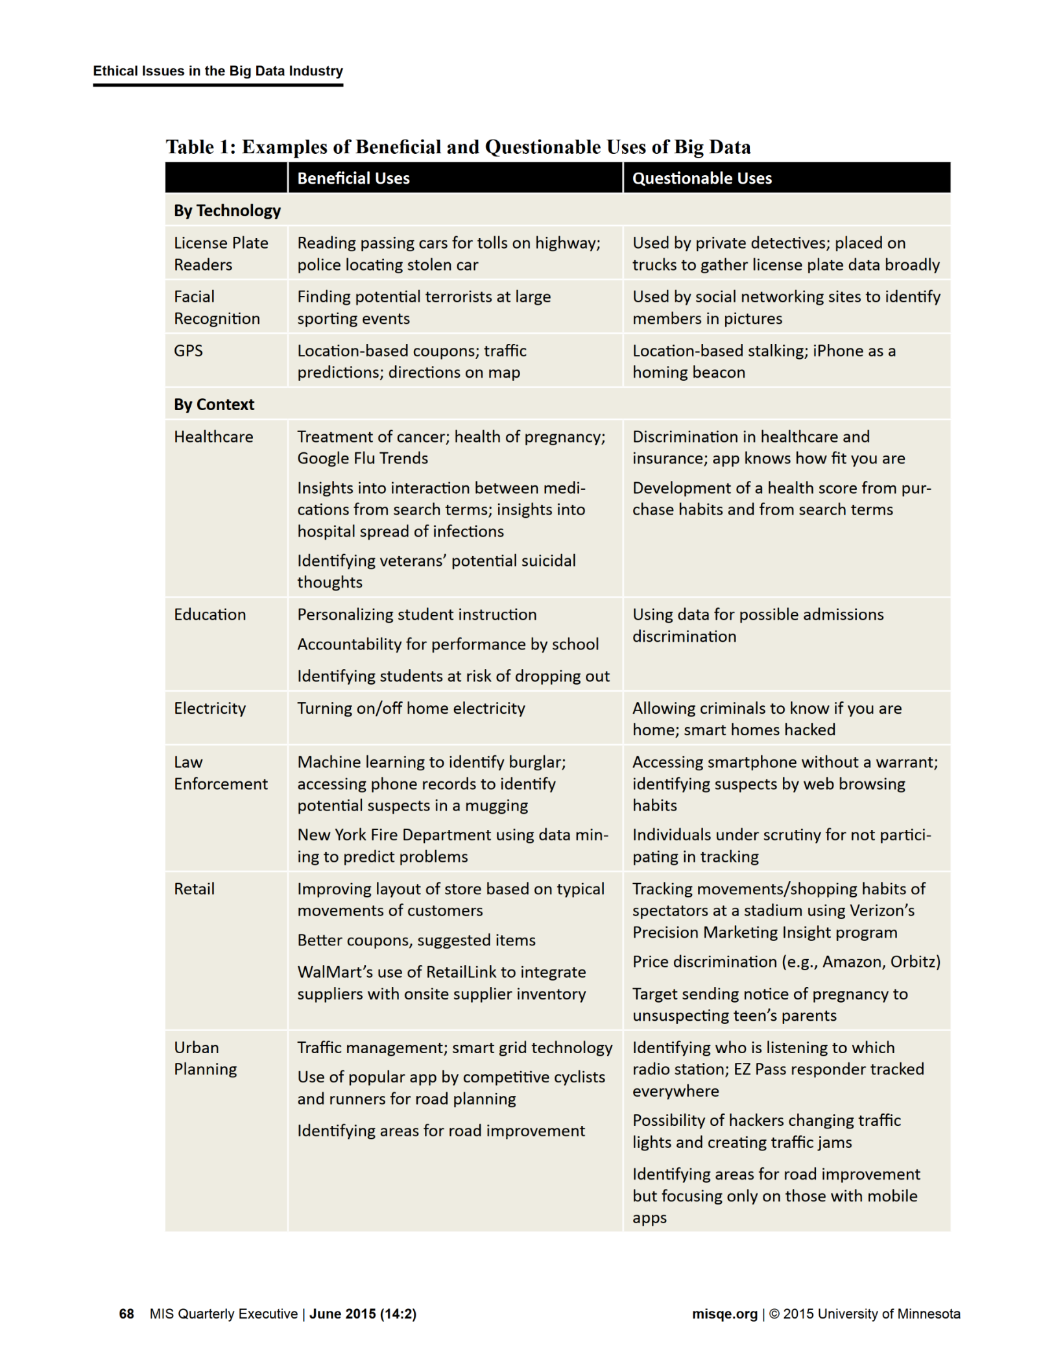

So based on the above table, there should be rules for data analytics in order to follow the golden rules:

* United States: privacy laws (e.g., HIPAA 1996, COPPA 1998, FACTA 2003),   
  Negligence laws
* European Union: General Data Protection Regulation (GDPR), some main rules:
* Data analytics must be fair.
* You need permission to process data.
* Individuals are allowed to access personal data and correct it if it's not correct.
* Accountability.

A traditional method for analyzing legal problems includes 4 parts: Issue, Rule, Application, and Conclusion (IRAC)

* Issue: define the legal problem
* Rule: identify laws that are applicable to the Issue
* Apply: analyze the Issue according to the Rule
* Conclusion: make a legal conclusion to the Issue

Whose fault: AI’s or humans?

On May 7, 2016, a Tesla Model S Gao Yaningcrashed while running in Autopilot semi-autonomous driving mode in the city of Williston, Florida, USA. As a result, 45-year-old Joshua Brown, who was in the driver's seat of a Tesla Model S, died on the spot. It is known that this is the world's first fatal accident involving self-driving cars.

Police had initially concluded Model S Gao Yaning was responsible for the crash, but advised there was no evidence that the car's brakes had been applied. Tesla claimed the car had sustained too much damage to determine whether or not Autopilot was in use at the time of the accident.

## 4.2 Fundamental ideas and concepts

### 4.2.1. History of AI

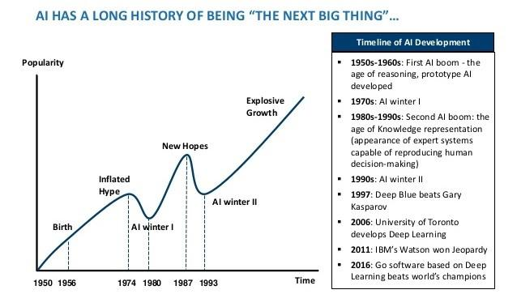

### 4.2.2. Four approaches to AI

* Thinking humanly: When a computer thinks as a human, it performs tasks that require intelligence (as contrasted with rote procedures) from a human to succeed, such as driving a car.
* Acting humanly: When a computer acts like a human, it best reflects the Turing test, in which the computer succeeds when differentiation between the computer and a human isn’t possible.
* Thinking rationally: Studying how humans think using some standard enables the creation of guidelines that describe typical human behaviors. A person is considered rational when following these behaviors within certain levels of deviation. A computer that thinks rationally relies on the recorded behaviors to create a guide as to how to interact with an environment based on the data at hand.
* Acting rationally: Studying how humans act in given situations under specific constraints enables you to determine which techniques are both efficient and effective. A computer that acts rationally relies on the recorded actions to interact with an environment based on conditions, environmental factors, and existing data.

### 4.2.3. Foundation of AI

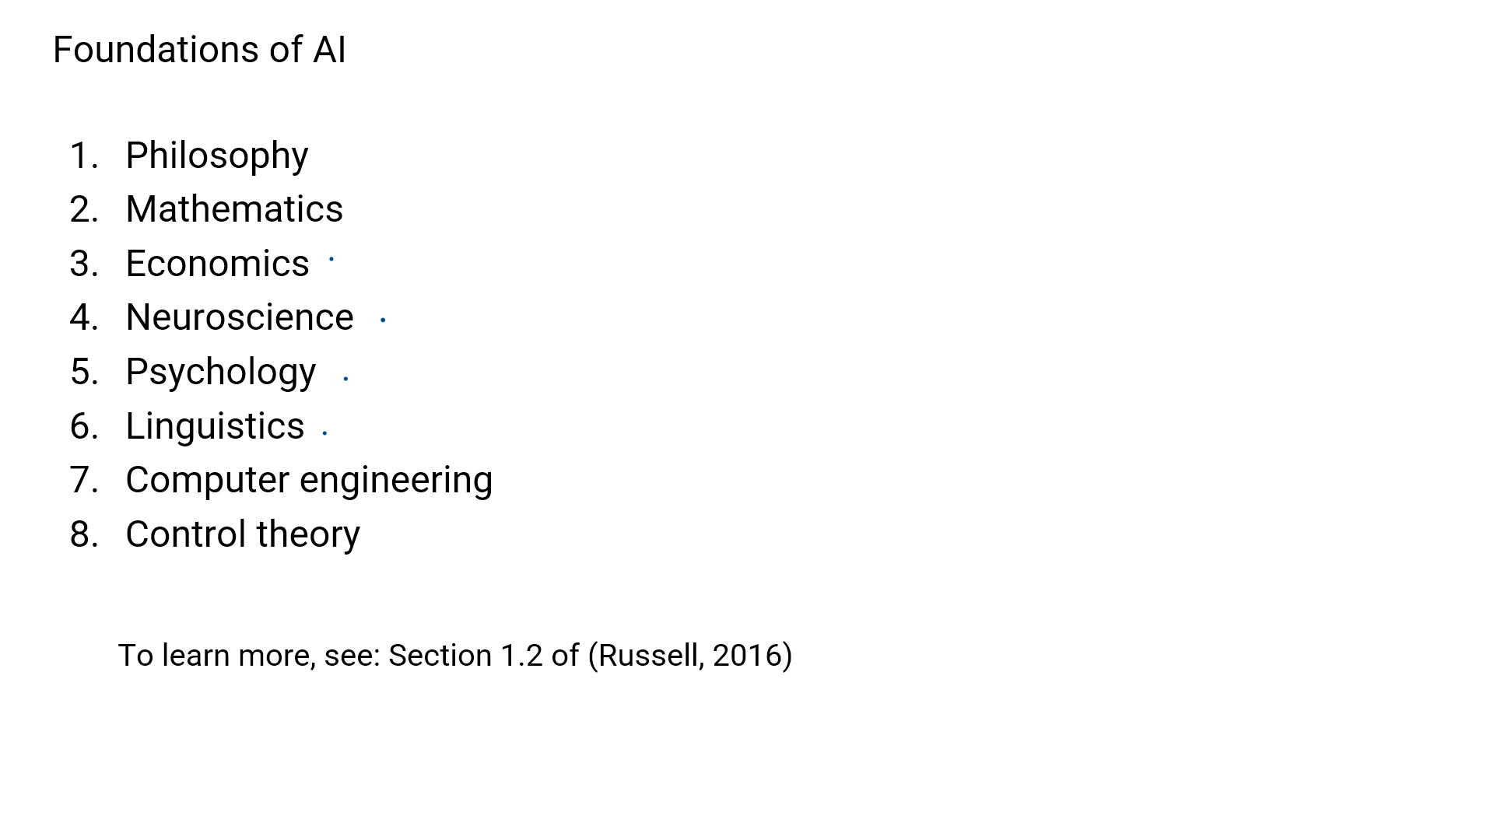

### 4.2.4. Basic concepts of AI

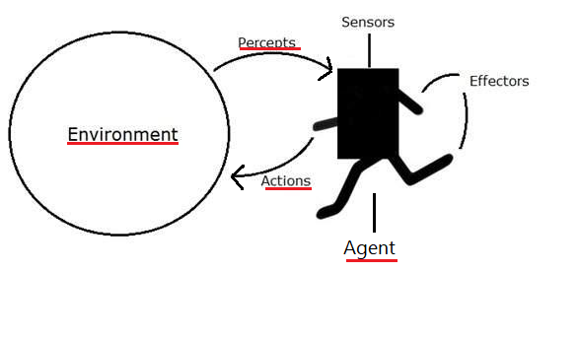

Examples:

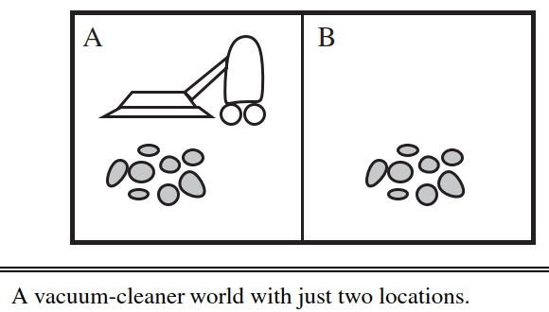

Environment: two locations

Agent: a vacuum-cleaner

Percept: two locations are dirty

Action: clean location(s)

### 4.2.5. Reward system

In AI systems, the rewards are calculated mathematically. This signal allows the agent to evaluate its performance. The algorithm then learns through trial and error to maximize the reward — and ultimately, complete the task in the most desirable manner.

Examples for above vacuum-cleaner

S1: The agent gets a point when it cleans an amount of dirt => bad reward system is not optimized when an agent is a fraud (it cleans dirt but the room is still dirty)

S2: The agent gets a point when a location is clean for one-hour => still a bad reward system because the agent may clean one room continuously

# CHAPTER 5: FUNDAMENTAL CONCEPTS

## 5.1. Exploit vs Explore

To help agents to improve their performance, we use to exploit and explore

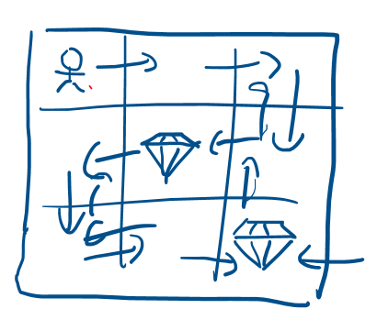

Exploit is when the agent will stop at some position that gives it a particular reward,

and Explore is when the agent will continue to move until it gets a better reward instead of stopping at one point.

An effective strategy is to force the agent to explore most of the time in the beginning and exploit the later.

## 5.2. Environment

### 5.2.1. Fully observable, partially observable, and unobservable

When an agent sensor is capable to sense or access the complete state of an agent at each point in time, it is said to be a fully observable environment else it is partially observable.

Maintaining a fully observable environment is easy as there is no need to keep track of the history of the surrounding.

An environment is called unobservable when the agent has no sensors in all environments.

### 5.2.2 Single-agent vs Multi-agent

An environment consisting of only one agent is said to be a single-agent environment.

An environment involving more than one agent is a multi-agent environment.

### 5.2.3. Episodic vs Sequential

In an Episodic task environment, each of the agent’s actions is divided into atomic incidents or episodes. There is no dependency between current and previous incidents. In each incident, an agent receives input from the environment and then performs the corresponding action.

In a Sequential environment, the previous decisions can affect all future decisions. The next action of the agent depends on what action he has taken previously and what action he is supposed to take in the future.

## 5.3. State presentation

A state is a time snapshot representing some aspect of the problem. It is common to practice modeling a problem as a state space or a collection of possible states to understand it better. If an operation can change one state into another, then the two states are connected in the set of states' graphs. There are three models of state:

Atomic models have no internal structure; the state either does or does not match what you're looking for. In a sliding tile puzzle, for instance, you either have the correct alignment of tiles or you do not.

Factored models have more internal structure, although exactly what will depend on the problem. Typically, you're looking at variables or performance metrics of interest; in a sliding puzzle, this might be a simple heuristic like "number of tiles out of place," or "sum of Manhatten distances."

Structured models have still more; again, exactly what depends on the problem, but they're often relations either of components of the model to itself, or components of the model to components of the environment.

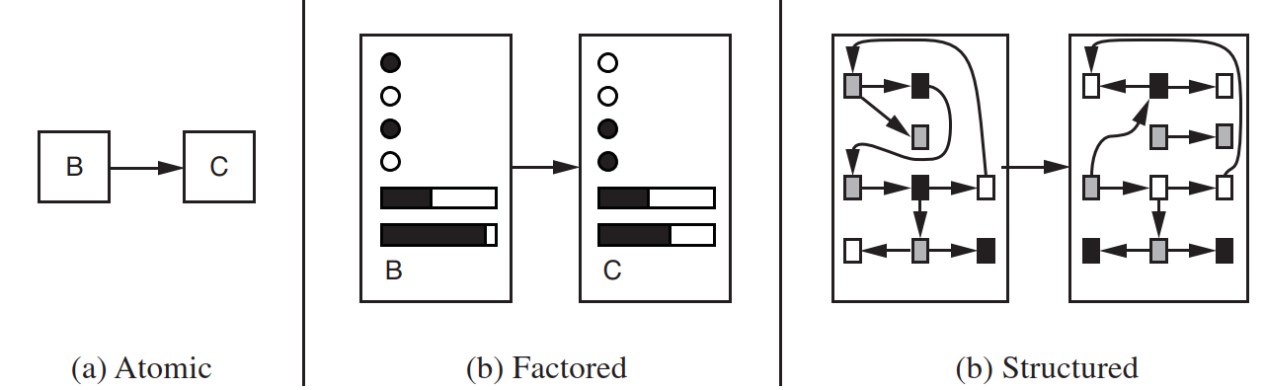

## 5.4. Solving problem by searching

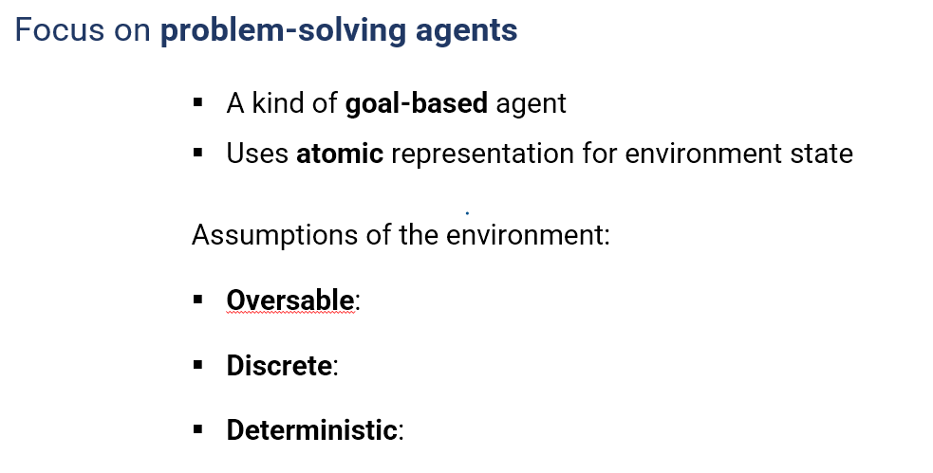

*Components of a problem*

1. Initial state: a state that the agent starts in.

2. Possible actions: actions that are applicable to the agent at a given state.

3. Transition model: the result of an action in a state.

4. Goal test: determines whether a state is a goal state.

5. Cost: a performance measure (lower is better).

*Examples:*

1. Initial state: Start state

2. Possible actions: Up, down, left, right (for the empty box)

3. Transition model: the new state has an empty box that was moved

4. Goal test: Goal state

5. Cost: one per action.

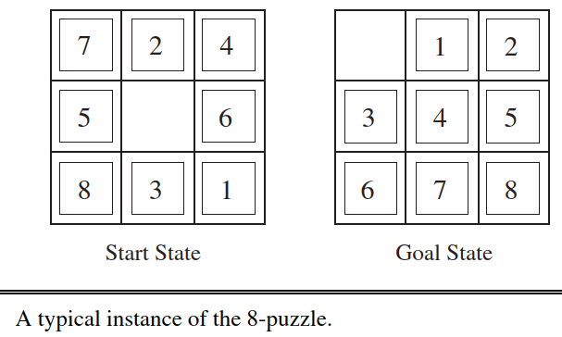

## 5.5. Searching for solution

### 5.5.1. Problem

Two main steps of search algorithms

1. Choose a node

2. Expanding the node

Repeat these 2 steps until reach the goal.

*Examples:*

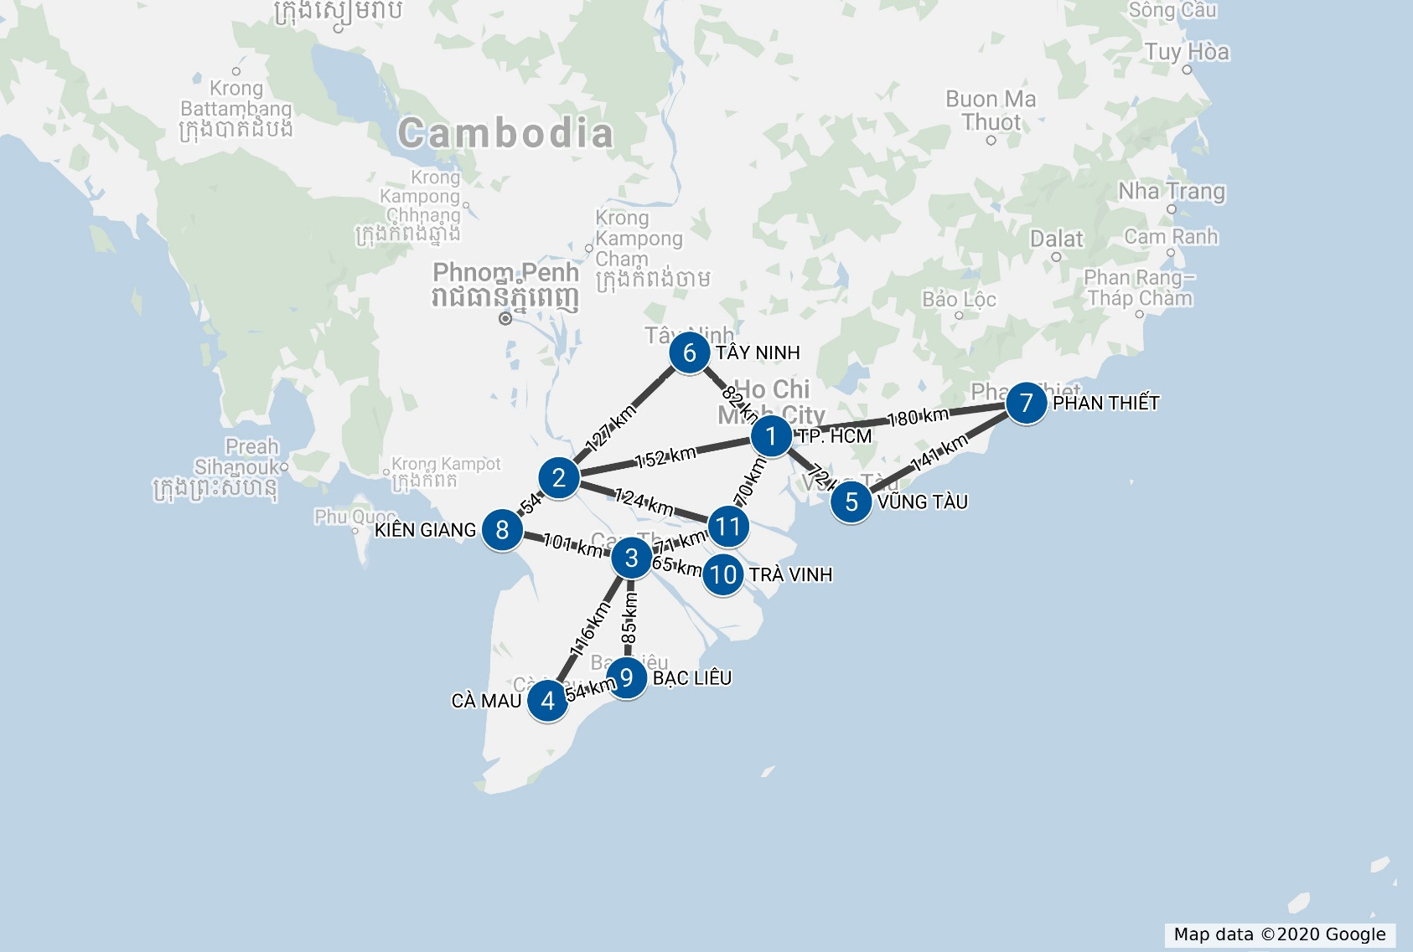

AN GIANG



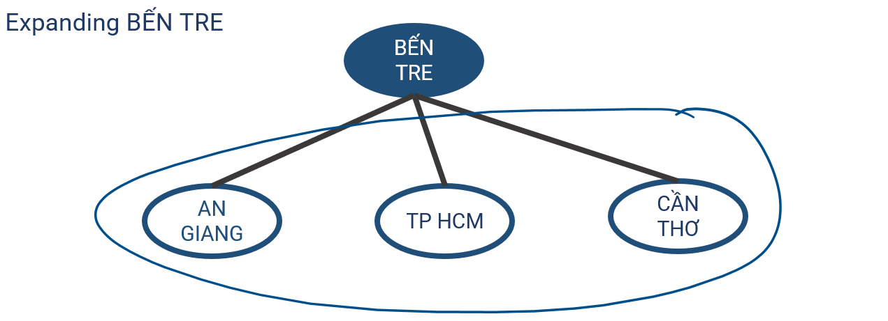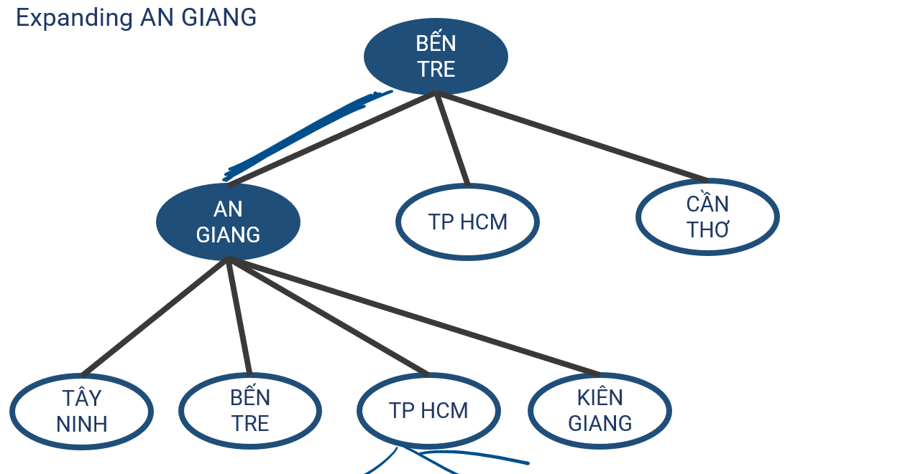

### 5.5.2. Tree Search

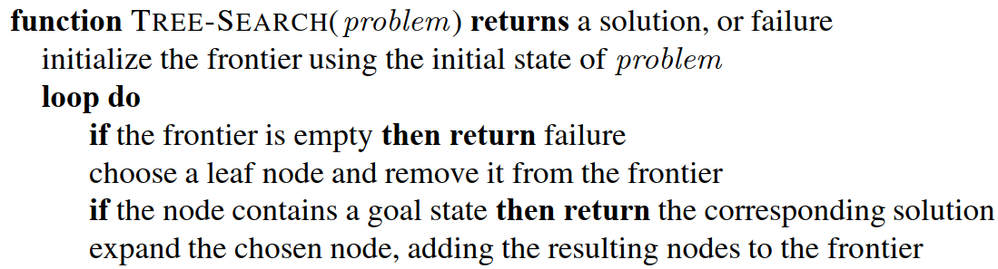

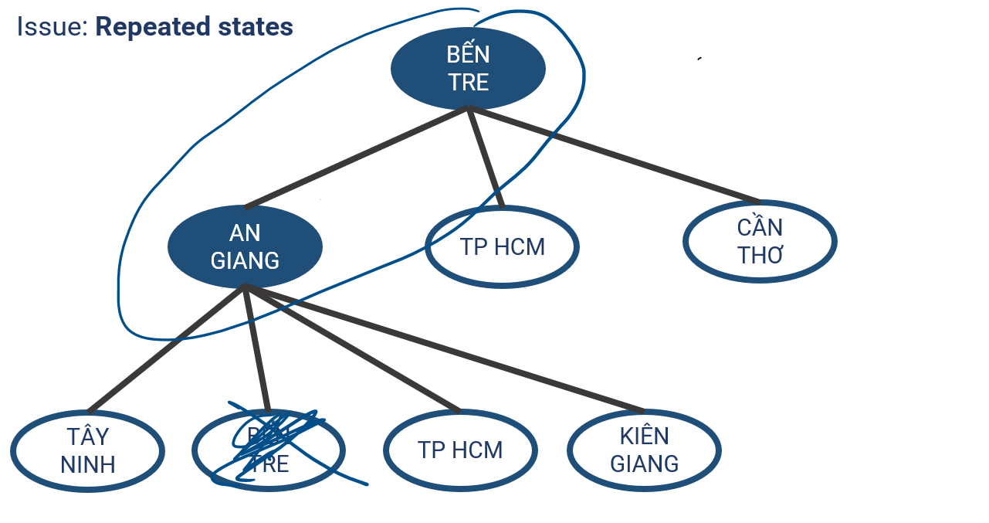

As we can see, with this problem, the agent may be stuck in an infinite loop between the An Giang Node and Ben Tre Node. So we come to a new algorithm.

### 5.5.3. Graph Search

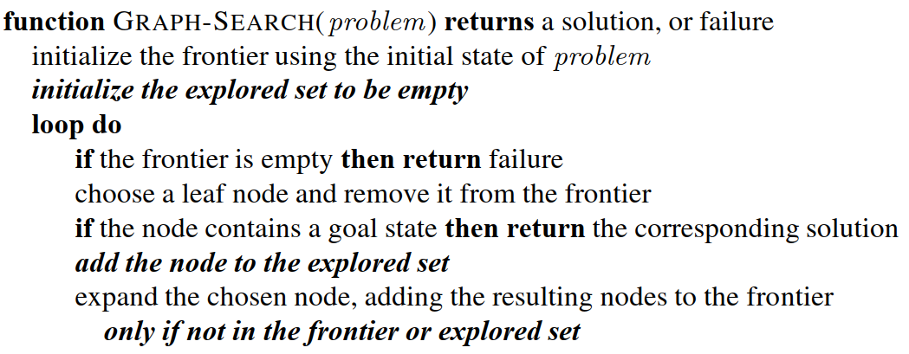

# CHAPTER 6: UNINFORMED SEARCH:

## 6.1. First method: Breadth–first search

* The root node is expanded first, then all the successors of the root node are expanded next, then their successors, and so on.

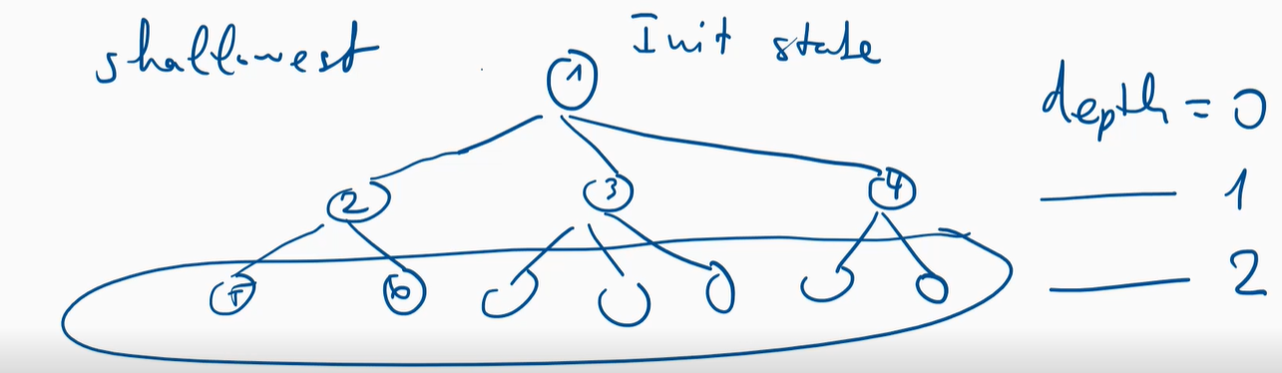

* Breadth–first search. Select the nodes with the smallest depth. In case the frontier set has the same depth, the algorithm will choose the node from the left.

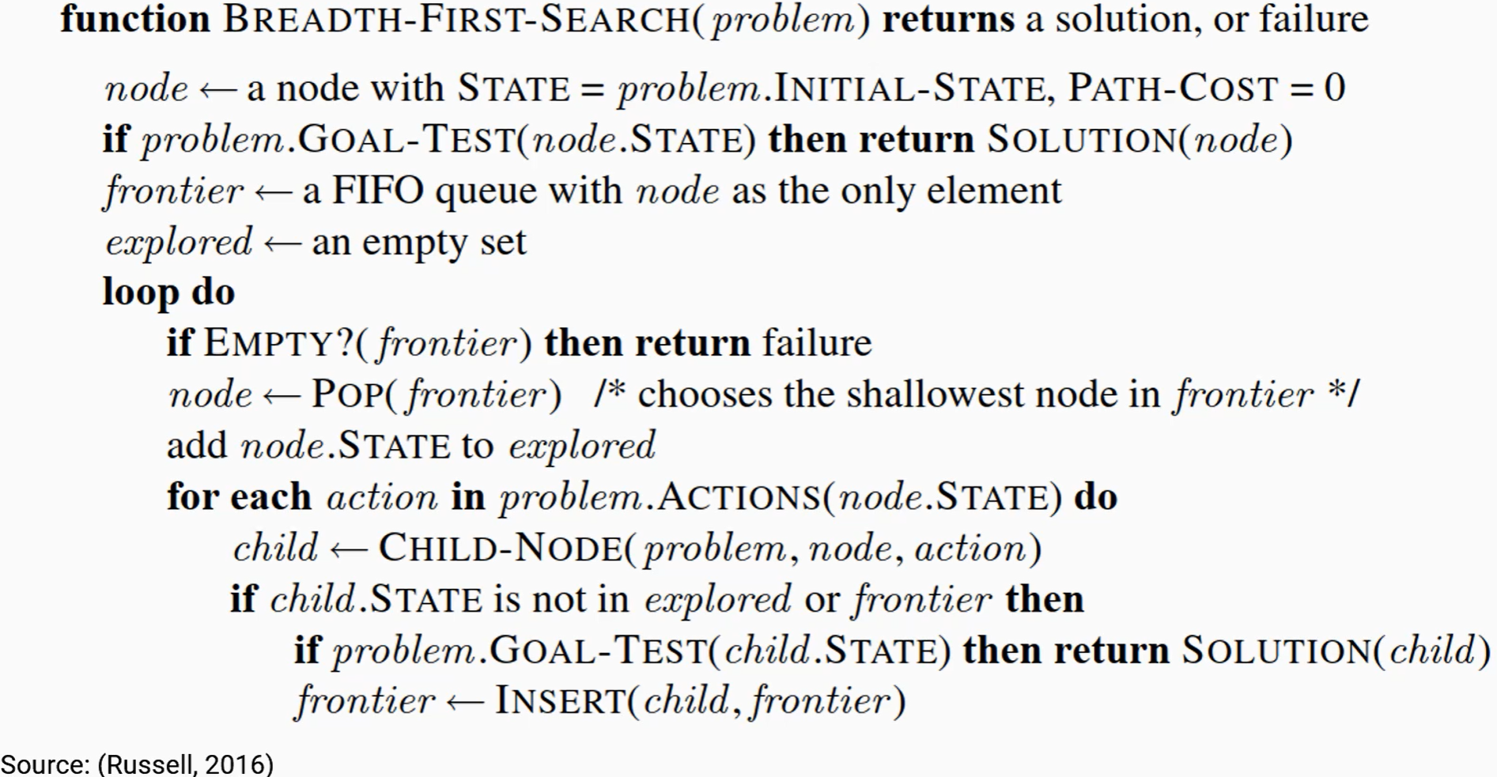

## 6.2. Components of a node: A node will be a class and has 4 properties:

* STATE: Indicate what state the node represents
* PARENT: Indicates which node will be the parent of the selected node
* ACTION: Is the Action of the parent node that spawned it.
* PATH-COST: Cost goes from node init state to node n. Used to make calculations easier
* Function CHILD-NODE(problem, parent, action): The function creates a new child node with all 4 components.
* Queues: Queue stores data like arrays, but cannot take arbitrary elements like arrays. Queue retrieves data at a location and inserts data at a predefined location. The queue is very useful in order control.
* Functions of Queue:
  + EMPTY(QUEUE): The function checks if the Queue is empty. Returns True if not null, returns False if empty.
  + POP(QUEUE): Retrieve an element from a Queue.
  + INSERT(element, queue): Insert an element into the Queue.

## 6.3. Three common variants of queues:

* FIFO queue(first-in,first-out): queue. The data that comes in first will come out first
* LIFO queue(last-in,first-out, aka a stack): like a stack. Data entered first but will be retrieved last
* Priority queue: Depends on the priority of the data. Data with higher priority will be retrieved first

## 6.4. BFS Demo:

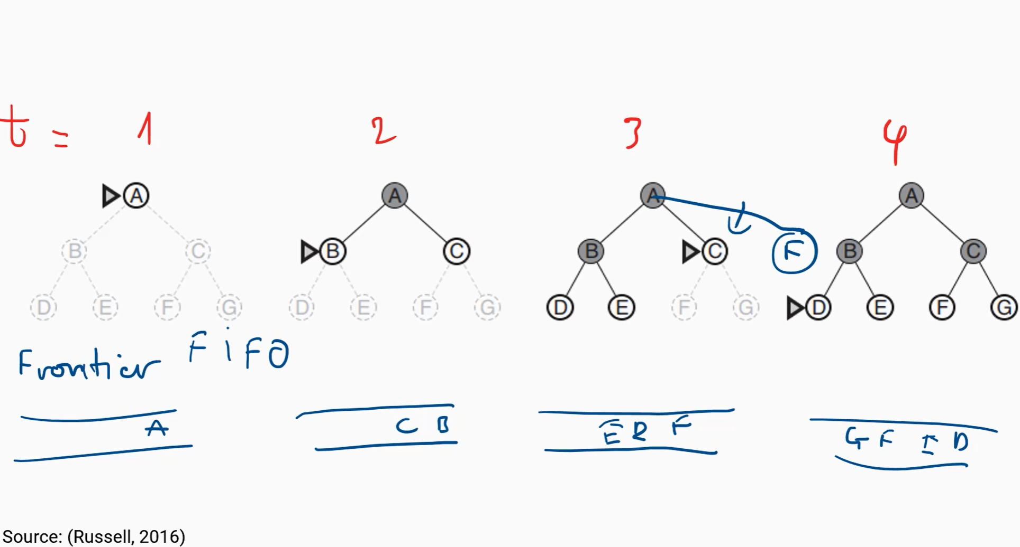

* BFS can find an optimal solution if the path cost is a non-decreasing function of the depth
* Measuring algorithm’s performance:
* Completeness: The algorithm exists a solution, sure to find it is called complete. If the algorithm has a solution but the running algorithm cannot find it, it is called not complete. BFS is a complete algorithm
* Optimal: An algorithm is called optimal if the solution returned is an optimal solution. BFS is a conditional optimal algorithm.
* Complexity: The complexity of the algorithm
  + + Time complexity
  + + Memory complex set
  + Statistics on the complexity of the BFS.
* Algorithm:

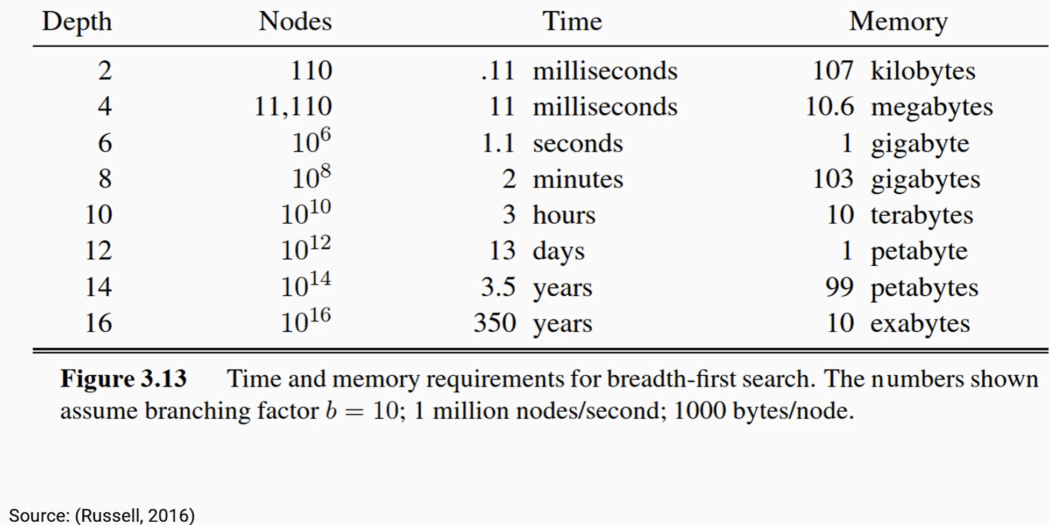

## 6.5. Uniform-cost search algorithm:

- An optimal algorithm with no conditions. It solves the problem of the BFS.

- Algorithm:

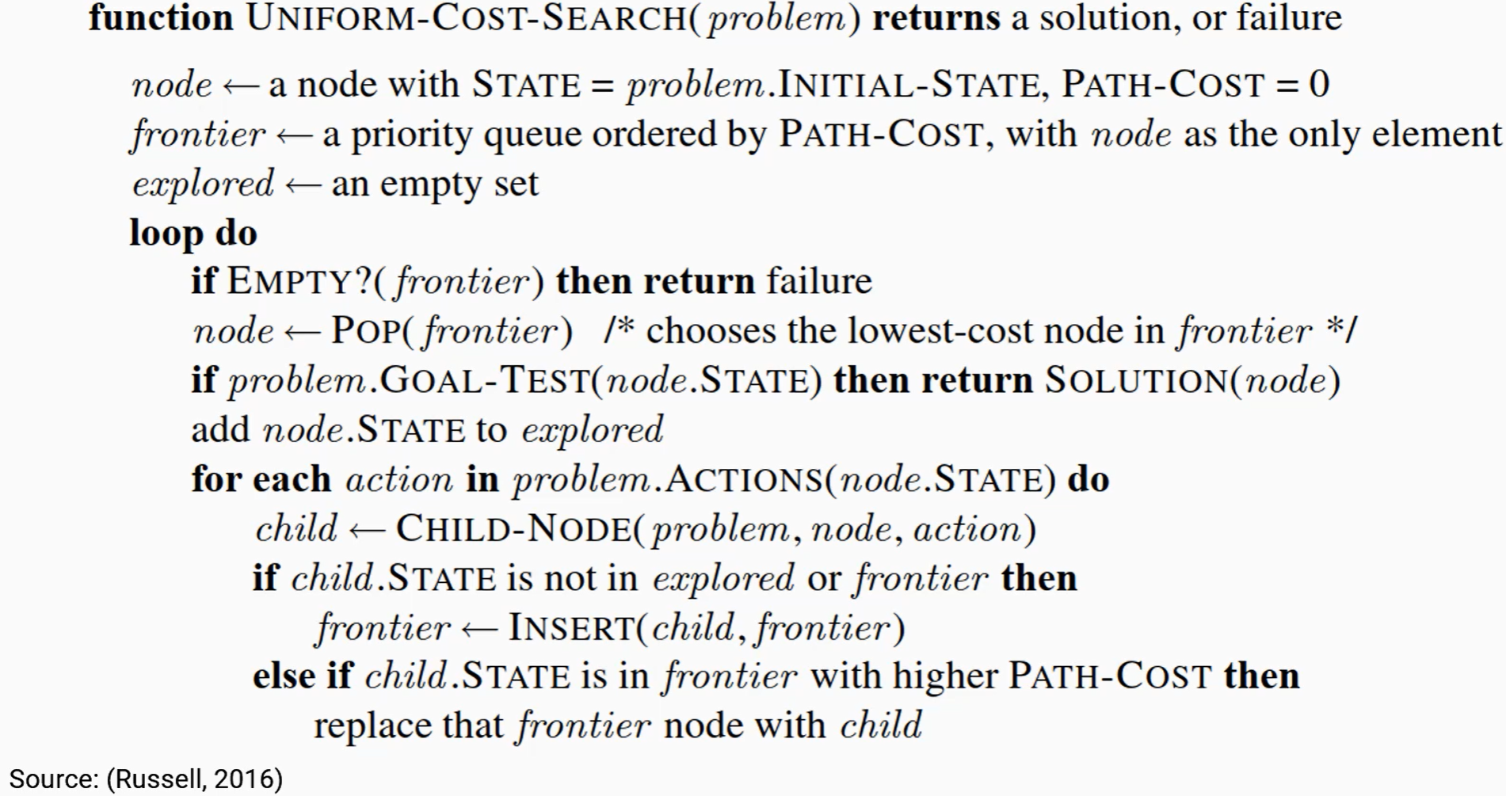

## 6.5. Difference of Uniform-cost-search from breath-first search:

+ The frontier of Uniform-cost-search is defined by PATH-COST precedence. The smaller the PATH-COST, the higher the priority. Solve the optimal problem

+ Update frontier

## 6.6. DFS Demo:

* Depth-first search (DFS): Frontier of DFS is defined by LIFO queue

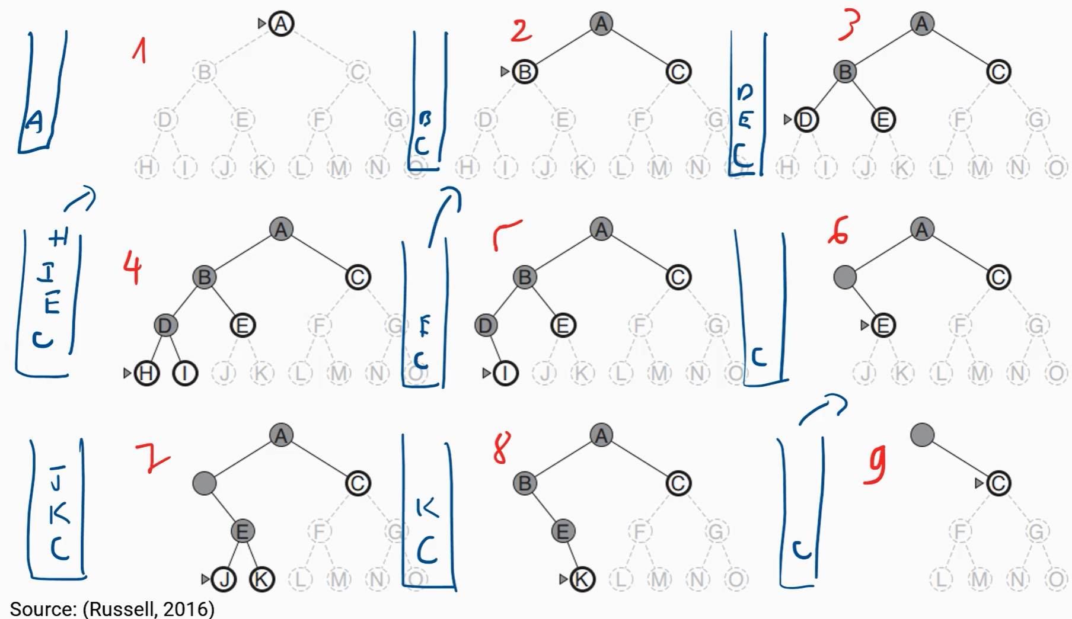

* Algorithm:

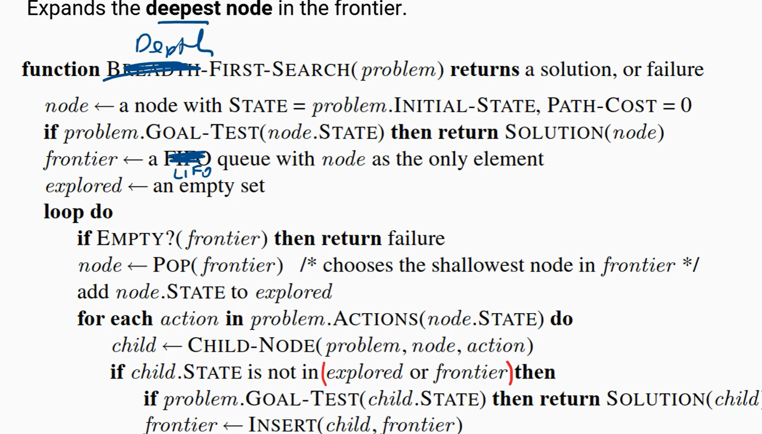

* DFS versus BFS:
  + BFS is optimal (with the condition). DFS is nonoptimal
  + DFS is better than BFS in space complexity
* DFS fails when encountering an infinite non-goal path

## 6.7. Iterative deepening search

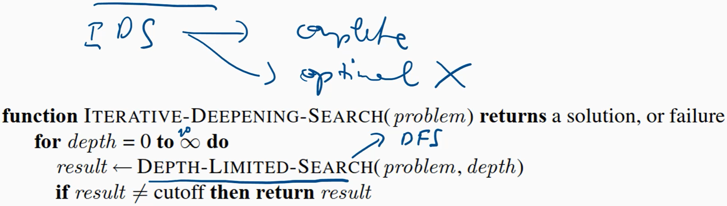

* Comparing uninformed search strategies

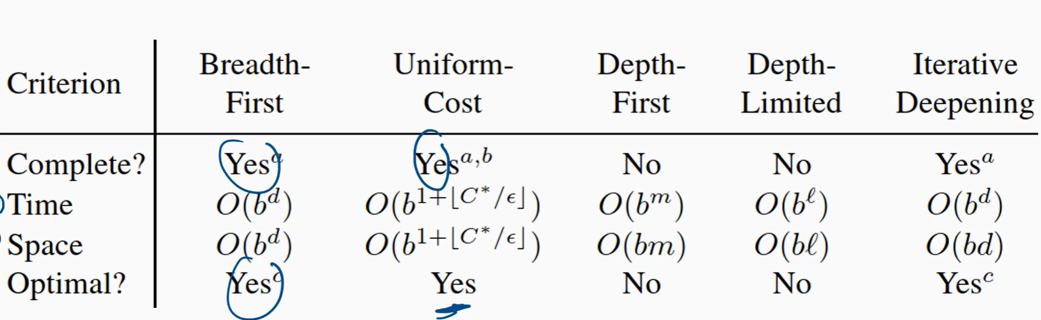

Iterative deepening combines the benefits of depth-first and breadth-first search:

* Like depth-first search: good about complexity
* Like breadth-first search: good about optimal

## 6.8. Depth-limited search (TREE-SEARCH version)

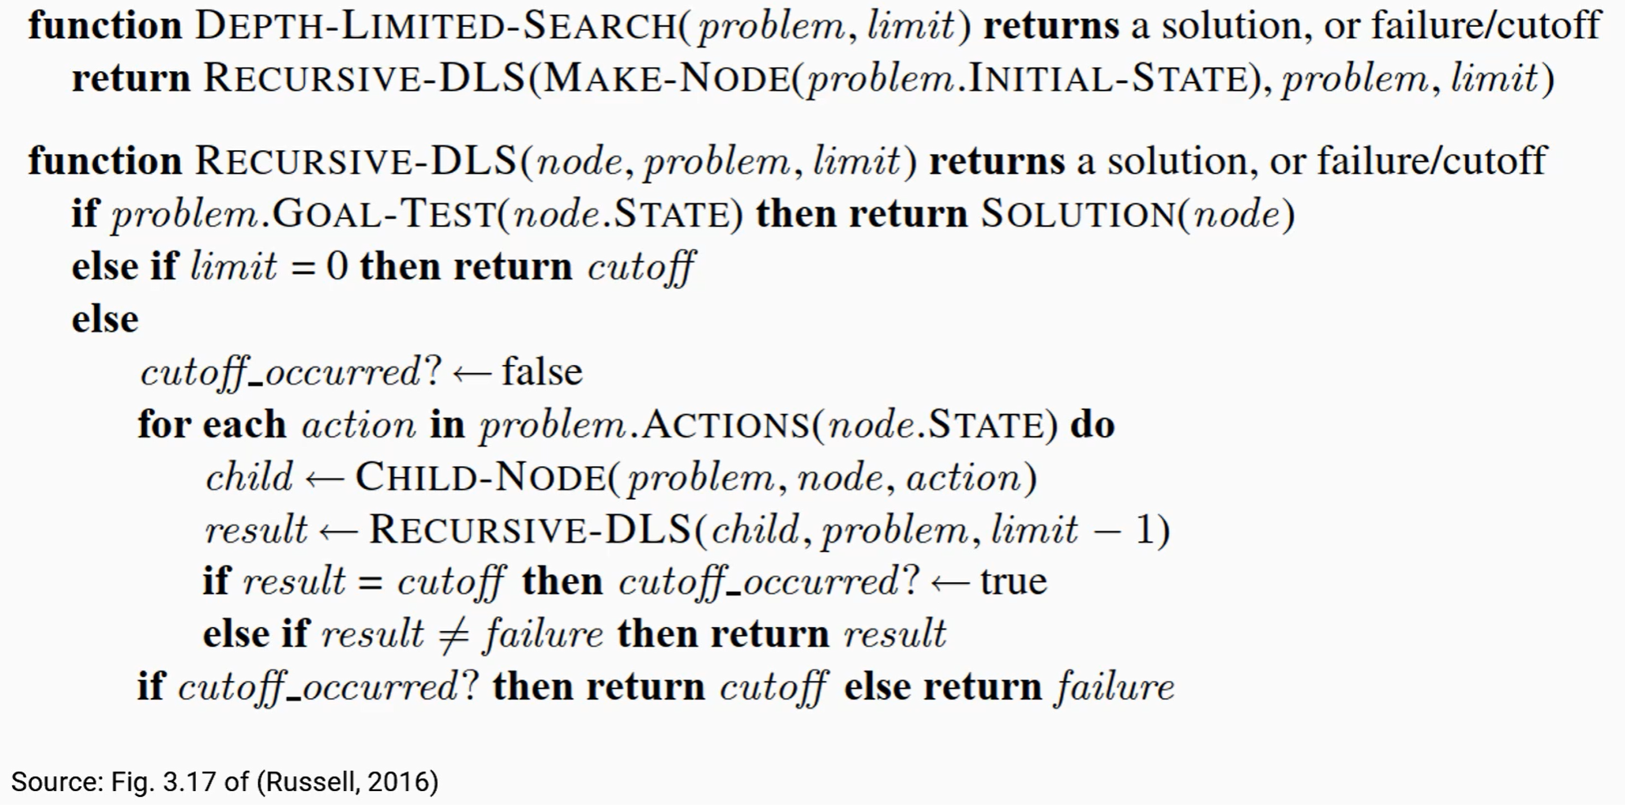

# CHAPTER 7. INFORMED SEARCH:

## 7.1. Uniformed vs Informed strategy:

* Uninformed: Randomly choose a path to take. If that path does not lead to the destination, then go back and take another route
* Informed strategy: At the turn, the algorithm will be given a little bit of information to choose the better route to take.

## 7.2. Evaluation function f(n):

* f(n)is the estimated cost of going from the initial state to the goal state through n.
* Example: cost estimate of going from HCM to AnGiang can be a straight distance. The idea of an informed search strategy: A node is selected for expansion based on an evaluation function, f(n).
* Steps to run Informed search algorithm:
* B1: Select a node
* B2: Expand node with f(n) as priority queue

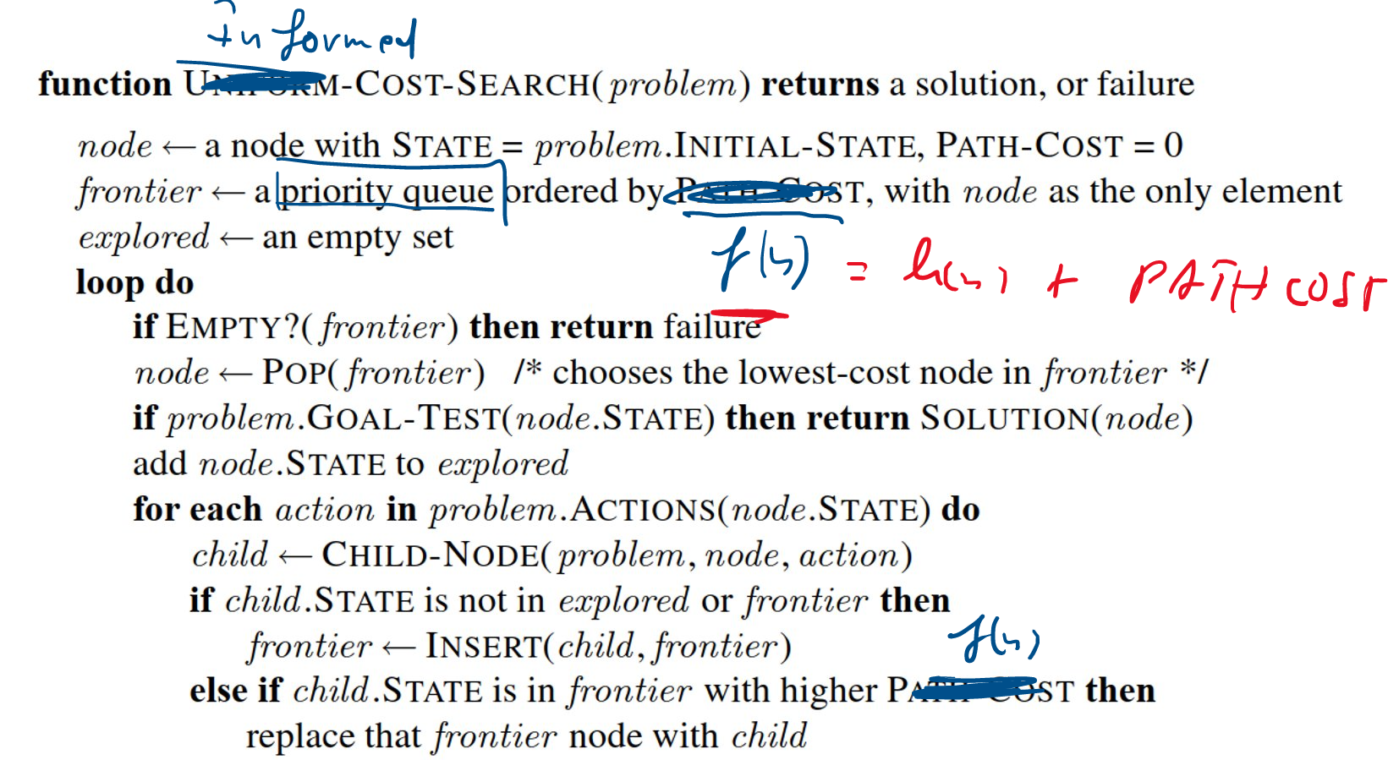

## 7.3. Best-first search:

* F(n) = h(n)
* Heuristic function h(n) estimates the cost of the path from node n to the goal.
* Example Best-first search vs Depth-first search:

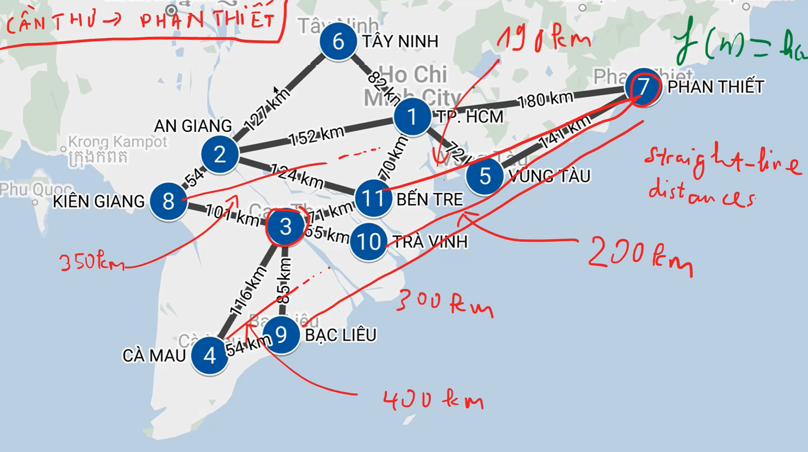

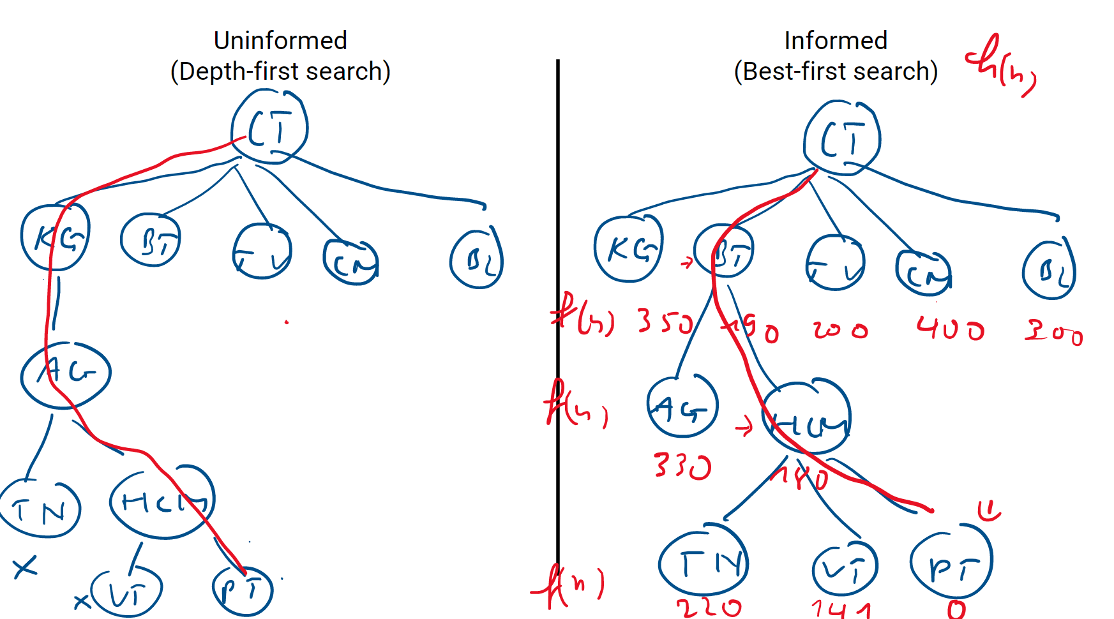

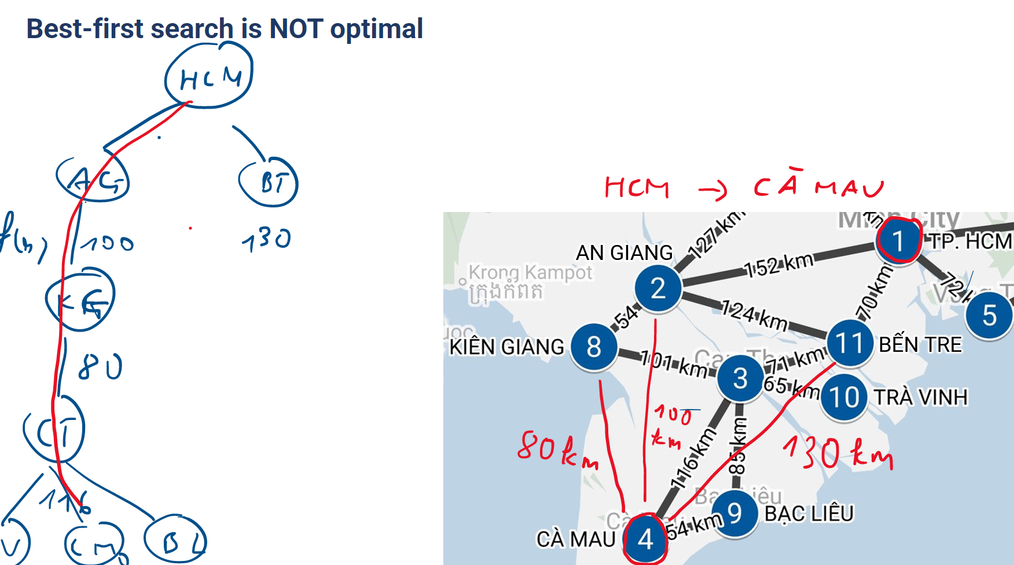

* Best-first search is NOT optimal because

1. No PATH-COST
2. H(n) is overestimated

* To solve the problem of Best-first search we have a* search algorithm:
* f(n)=n.PATH-COST + h(n)

## 7.4. A* search demo:

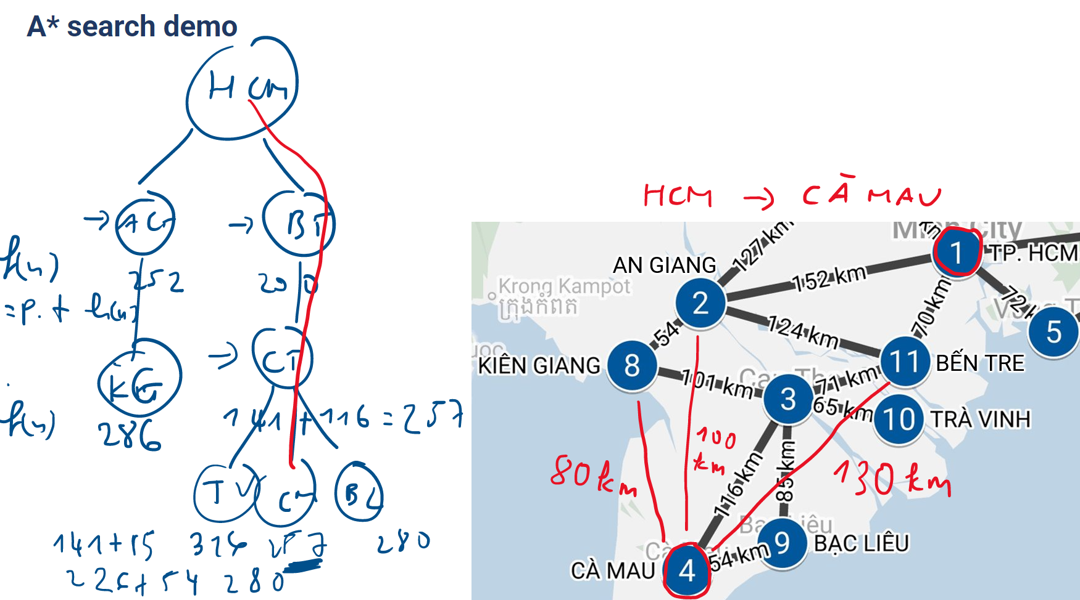

* A* search solved the problem No PATH-COST of Best-first search but the problem of H(n) overestimated is not solved.

A consistent heuristic satisfies h(n) ≤ cost(n,n’) + h(n’), for every node n and its successor n’. For functions with these heuristics, a* search ensures optimal

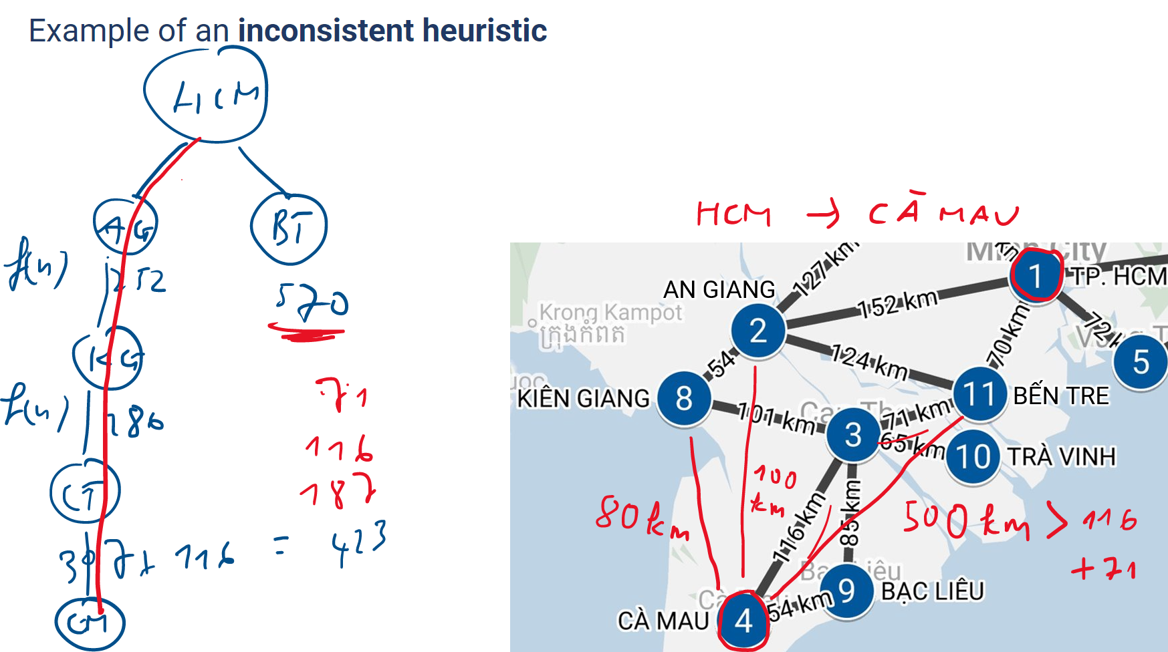

* If the inconsistent heuristic does not satisfy the above inequality, then the* algorithm will fail. Note on A* search: A* can be considered as an improved version of Uniform-cost search, which is a variant of breadth-first search.
* Heuristic function comparison:
* 0 heuristic vs accurate heuristic:
* If h(n) = 0 for all n, then f(n) = n.PATH-COST
* With a consistent heuristic close to actual cost

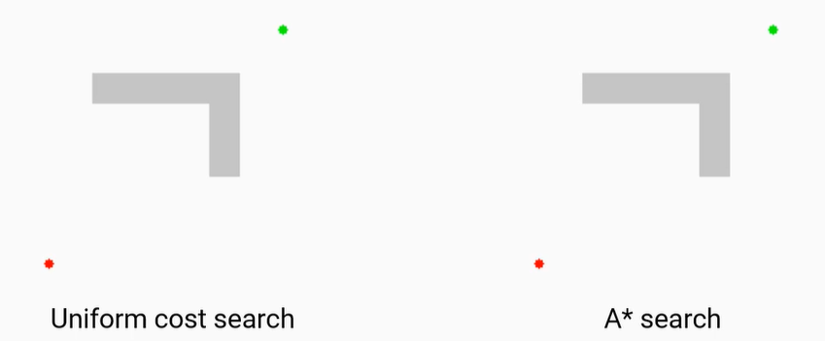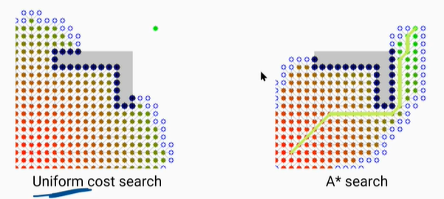

* + - Algorithm A* runs better
* Two heuristics for the 8-puzzle:
* h1 = the number of misplaced tiles = 8
* h2 = the sum of the distances of the tiles from their goal positions. Note: tiles cannot move along diagonals 🡪 city block distance = 18
* h2 is better than h1. Because h2 has a value bigger than h1

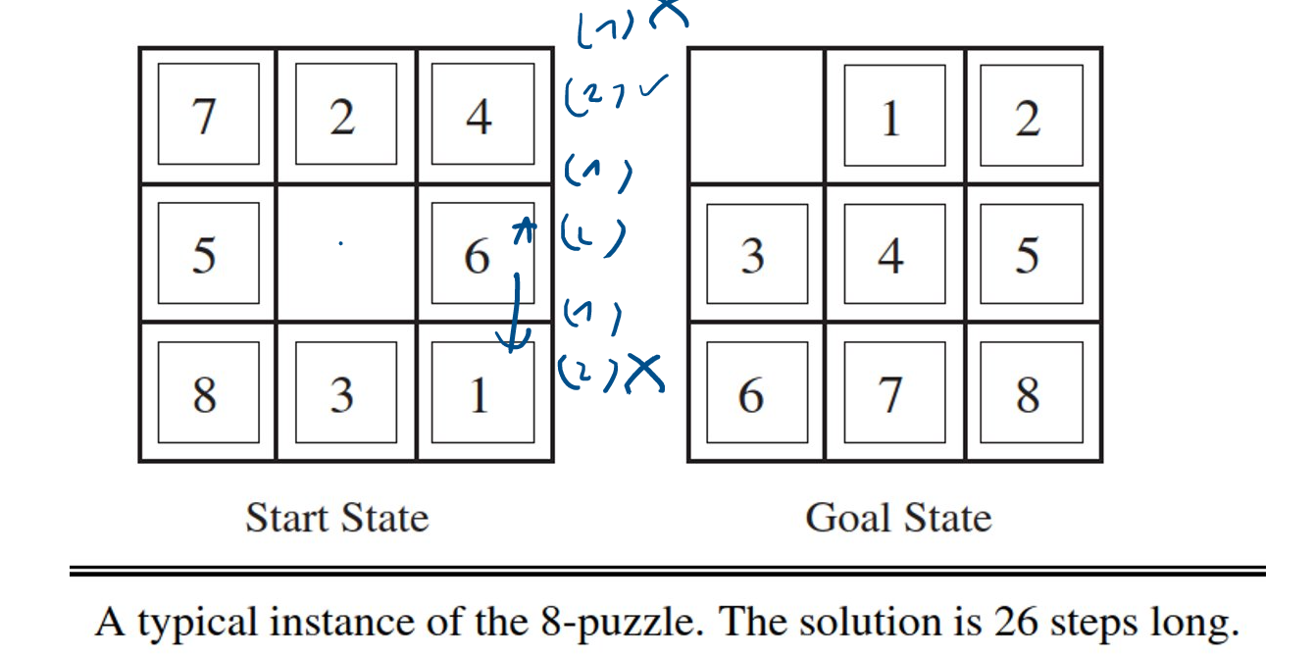

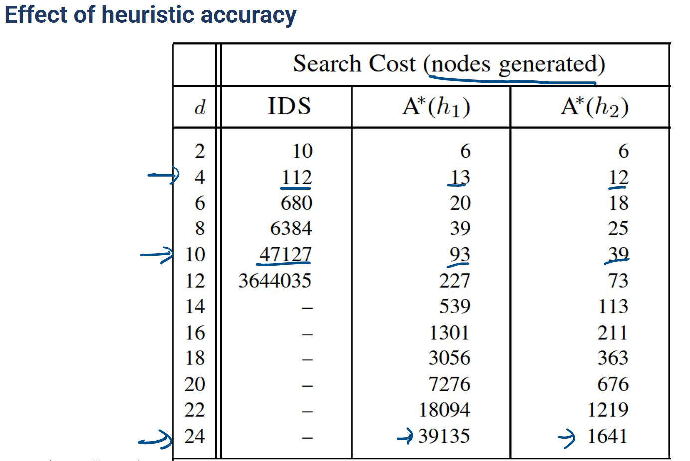

* It shows that using a*(h2) will generate fewer nodes than the other 2 algorithms

# CHAPTER 8: GENERATING HEURISTIC FUNCTIONS

## 8.1. Method 1:

Using relaxed problems

A relaxed problem: A problem with fewer restrictions on the actions,

For example, the 8-puzzle actions are described as a title that can move from square A to square B if A is horizontally or vertically adjacent to B (1) and B is blank (2)

h(n) = max{h1(n),…, hm(n)}

Three relaxed problems:

1. A -> B ⬄ (1)
2. A -> B ⬄ (2)
3. A -> B

## 8.2. Method 2:

Pattern databases

* Choose a subproblem.
* Construct the pattern database: store solution costs for every instance of the subproblem.

Notes:

* The database is constructed by searching back from the goal and recording the cost of each new pattern encountered.
* We could also construct databases for other subproblems

# CHAPTER 9: LOCAL SEARCH:

Previous searching algorithms requires:

Assumptions of the environment:

* Observable: A robot that knows where it is is fully observable, and if it doesn't know where it is, it's non-observable.
* Discrete: Its possible action is not a finite set
* Deterministic: One condition when performing the action, I will know 100% of the new state of the environment.

## 9.1. Local search – searching for goal states:

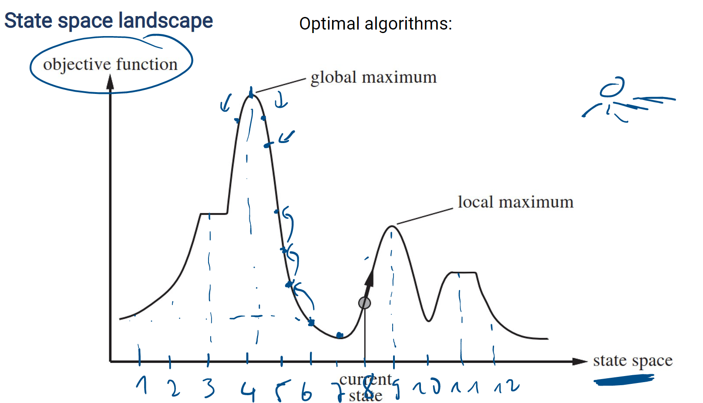

* Use only one current node and its neighbors

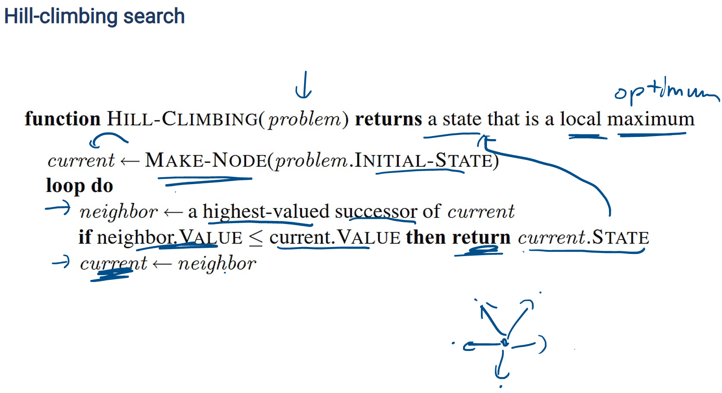

## 9.2. Problem:

There are 4 components that do not have Goal-test because the test is not found. Returns local maximum

## 9.3. How it works:

* Function MAKE-NODE: Initialize a node named current
* Loop:
* First we will try possible actions to find the successor with the highest value of the current state and then assign it to the neighbor variable
* Checks if the neighbor's value is less than or equal to current node's value, it will return the current state. This only happens when that node is the highest (goal).
* If it's wrong, the curet will jump to the higher button than continue

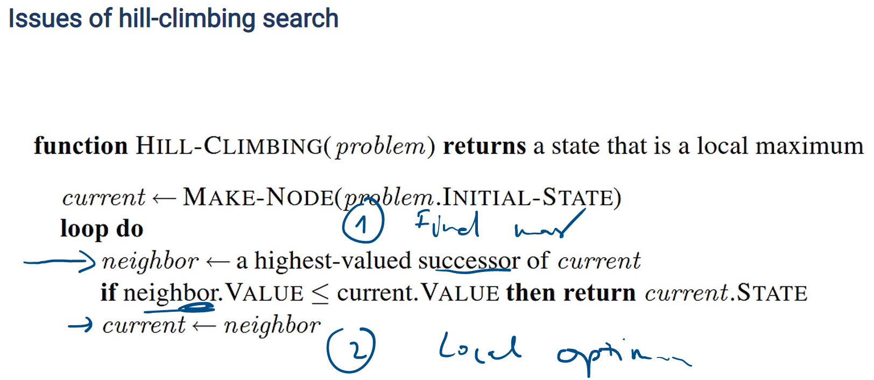

## 9.4. To overcome local optimal

### 1. Method 1:

- Random-restart hill climbing: Run with 1 random initialization position

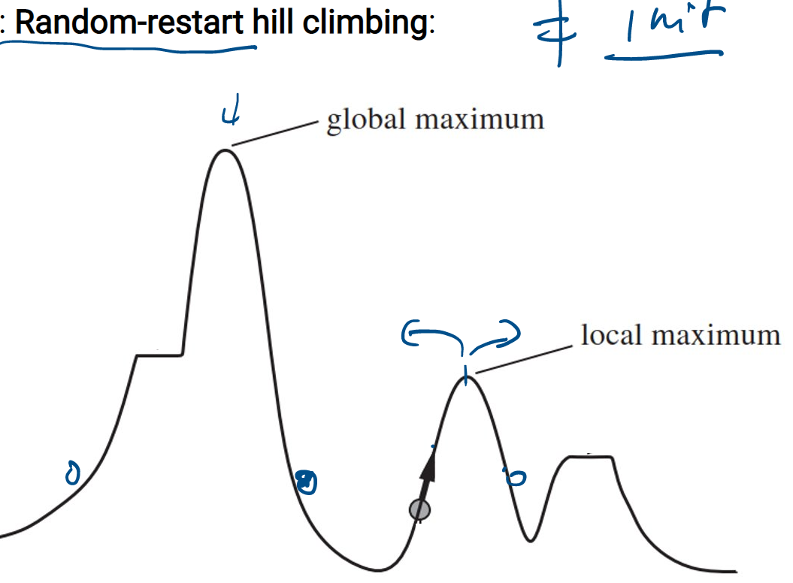

### 2. Method 2:

Local beam search: Run with multiple init states and run concurrently

* Instead of trying k random searches sequentially, do them simultaneously
* Local beam search: not just simultaneously

An improvement of local beam search: Stochastic beam search: combines Local beam search and Stochastic hill climbing.

### 3. Method 3:

Simulated annealing.

* Annealing: harden metals by heating them, then gradually cooling them

🡪 Material will reach a low-energy crystalline state (goal)

* Downhill-climbing:

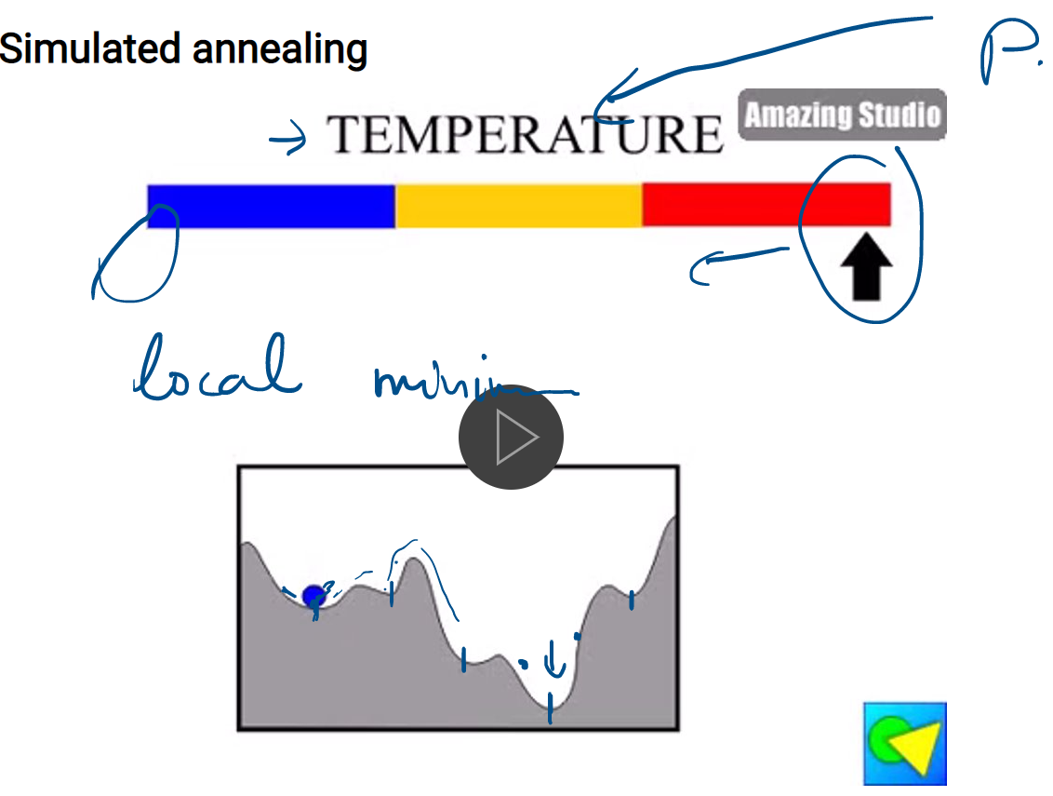

* Algorithm

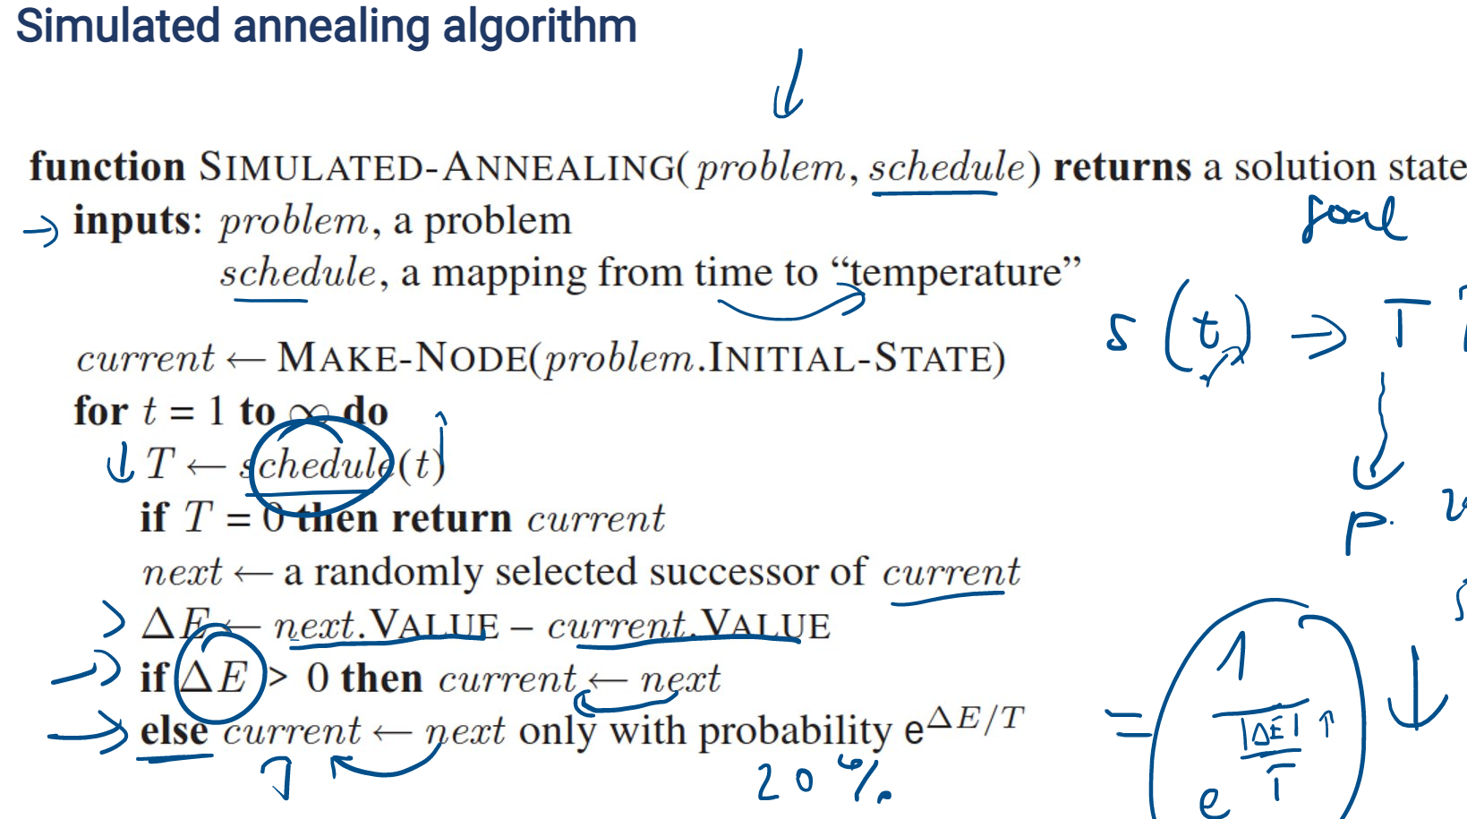

The function takes 2 parameters: problem, schedule – temperature function. The function returns the goal state

The loop runs endlessly. When T=0, stop, and when it's not 0, first, I will randomly choose a successor of the current and save it in the next state. Next, calculate delta E = value of state next – the value of the current state. If delta E > 0, then the new state is better than the old state. I will update the current state to the new state. And if delta E < 0, then also set the current state to the new state but with 1 probability.

# CHAPTER 9: AND-OR SEARCH

## 9.1. SEARCHING IN NONDETERMINISTIC ENVIRONMENTS

### 9.1.1. The vacuum world

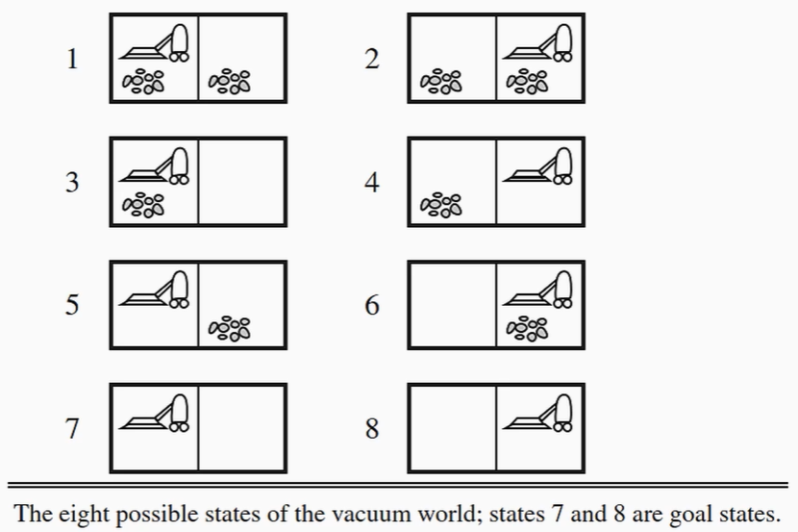

* We need 2 changes:

+ ***Transition model***: RESULTS function

Ex: RESULTS(1 ,suck) -> {1,5}

+ ***Solution***:

Ex: [suck, if s1 =5 then[right.suck] Elif s2 = 5 then []..]

### 9.1.2. And-or search tree

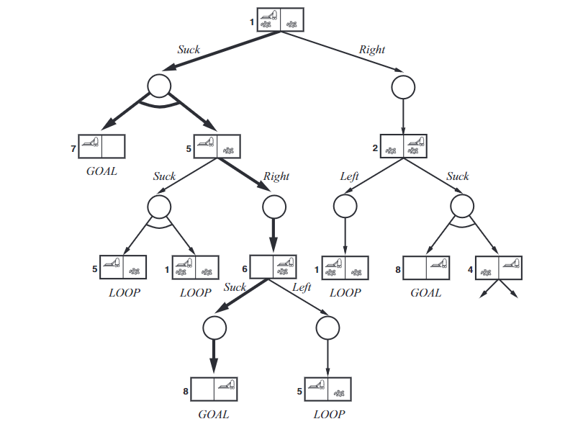

* ***OR nodes***: states
* ***AND nodes***: links

- In an ordinary search tree, there is ***a path***. In the AND-OR tree, there is ***a subtree(plan).***

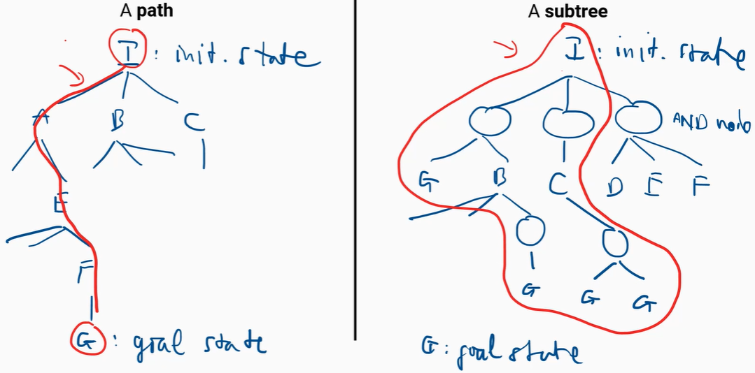

* There has only 1 goal state in the ordinary search tree. But in a subtree, ***all leaves*** of the tree must be the goal state. A ***solution*** in the AND-OR tree is a subtree that:
  + 1. All leaves nodes: goal states
    2. OR node: select 1 action
    3. AND node: select all actions
* **AND-OR graph search algorithm:**

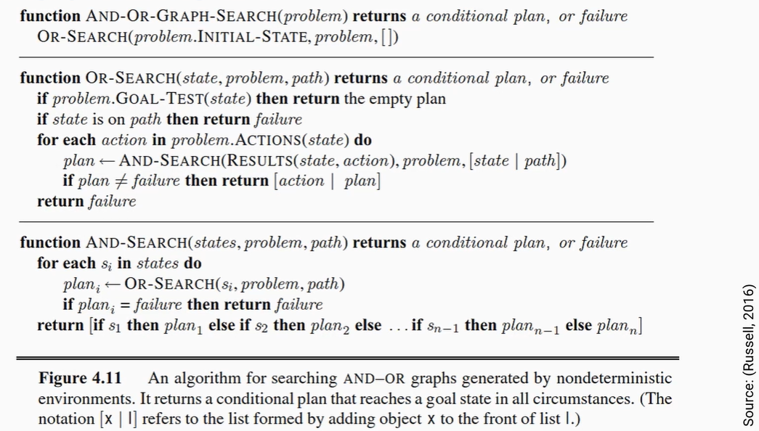

## 9.2. SEARCHING IN PARTIALLY OBSERVABLE ENVIRONMENTS

### 9.2.1. Searching with no observation

- Sensorless (physical environment) agents can be very useful.

- **Belief states** all sets of physical states.

- Components of a sensorless problem

1. **Initial belief state:** the set of all states
2. **Possible actions**: ACTION(belief state b) For example, b{s1,s2}, and ACTIONSp (s1) = {a, b, c}

ACTIONSp (s2) = {a, b, f}

ACTIONS (b) = {a, b}or {a, b, c, f}

1. **Transition model**: RESULT( belief state b, action a) = new belief state b’
2. **Goal test**: GOAL-TEST(b) = True (if all state of b is goal state)

= False otherwise

1. **Cost**: STEP-COSTp, PATH-COSTp

- Note: If the physical problem has **N state**, then you have 2N **belief states**

**=> Incremental belief-state search.**

* Solve 1 physical state at a time.
* Main advantage: quickly detect failure.

### 9.2.2. Searching in partially observable problems

*Component of partially observable problems*

- Problem formulation is the same as sensorless problems, except the transition model.

1. **State prediction**: b^’ = {s’: s’ = RESULTp(s, a) and s Є b}
2. **Observation**: O( o: o = PERCEPT (s) and s Є b) defining the set of acceptances that can be obstructed.
3. **State update**: determines, for each possible perception, the percept will result from the perception: b’= {s: o = PERCEPT(s) and s Є b}

Example 1:

+ Deterministic

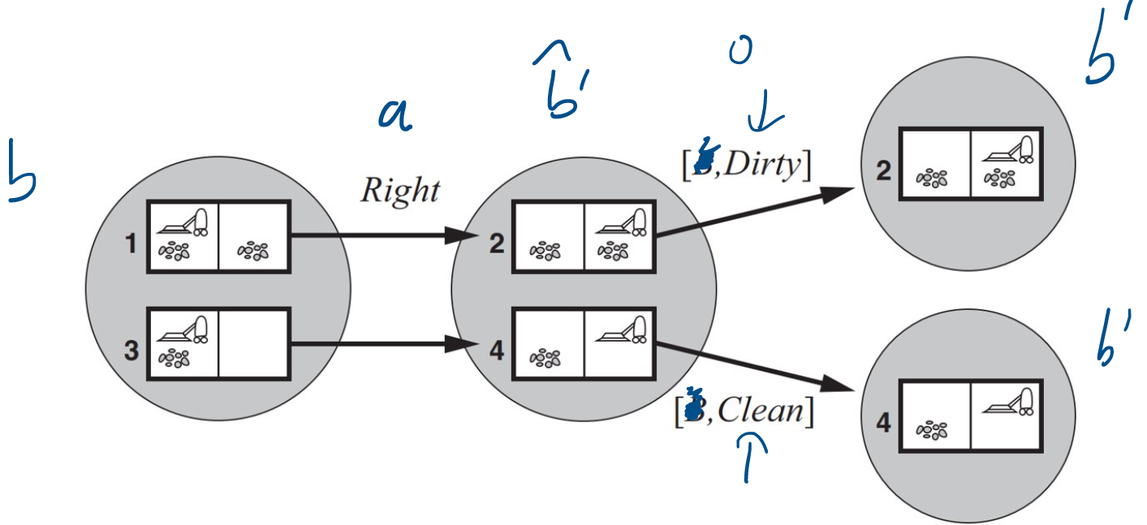

+ Nondeterministic

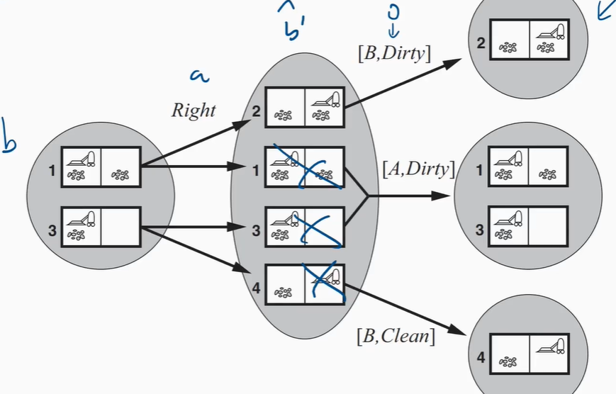

Example 2:

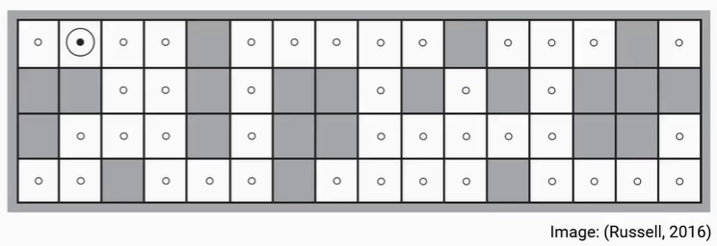

* Given a map, the robot has only 4 sonar sensors. To know where it is, the robot needs to
* Action - > predict -> b^’ = {…}(physical state) -> Update -> b={…} .
* Repeat until only 1 state remains
* After a move, it observes b’ = {1,2,3,4}

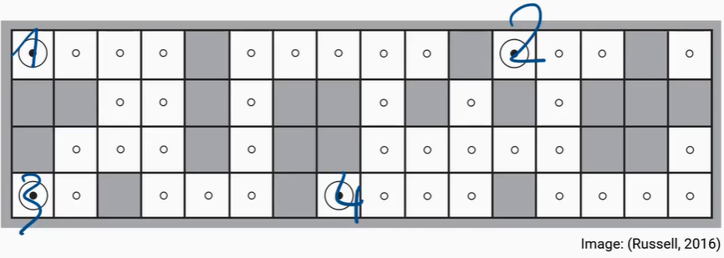

* After the 2nd, it observes b^’ = {1’, 2’, 3’, 4’} -> b’ = {1’}

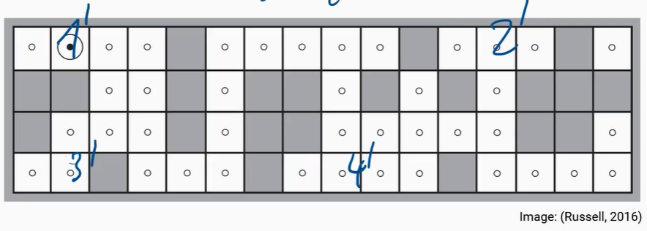

# CHAPTER 10: ONLINE SEARCH

## 10.1. GENERAL

- Searching with **no transition model** (RESULT)– online search

- Put the agent in the real environment to run

- Compare ***Offline search*** and ***Online search***.

|  |  |  |
| --- | --- | --- |
|  | **Offline** | **Online** |
| **Similar** | It's all about finding a way to a destination | |
| **Different** | * Runs for algorithms without transition model. * Run on an emulator | * A new transition model is required to run * Runs in real environment |
| **Application** | image classification | Weather forecast, stock price prediction |
| **Algorithm** | * Best First Search * Bread First Search * Uniform Cost Search | * Online depth-first search agent * Learning Real-time A* * Greedy Search |

### 10.1.1. Use, competitive ratio, and dead-end states

- Online Search algorithms are useful in

* There is a penalty for (too long computation)
* Non-deterministic environments
* No environment models

- There are 2 types of path costs in online search:

* Actual path cost
* Shortest path cost
* Competitive ratio = Actual path cost / Shortest path cost

- Dead-end states:

* Some actions are ***irreversible***, they lead to a dead-end state
* goal state never found(For example loop, die…)
* ***Safely explorable*** state space: is an environment where dead-end states do not exist.

### 10.1.2. Online depth-first search agent

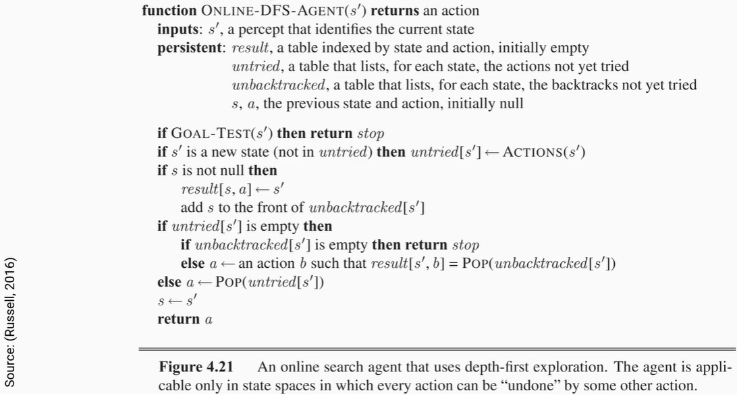

## 10.2. ONLINE SEARCH ALGORITHMS (ONLINE A*)

### 10.2.1. Idea

* ***Online A* search***: LRTA* (Learning Real-Time A*) algorithm
* At each step, from state s, the agent moves to the successor s' which has the best-estimated cost.

### 10.2.2. Algorithm

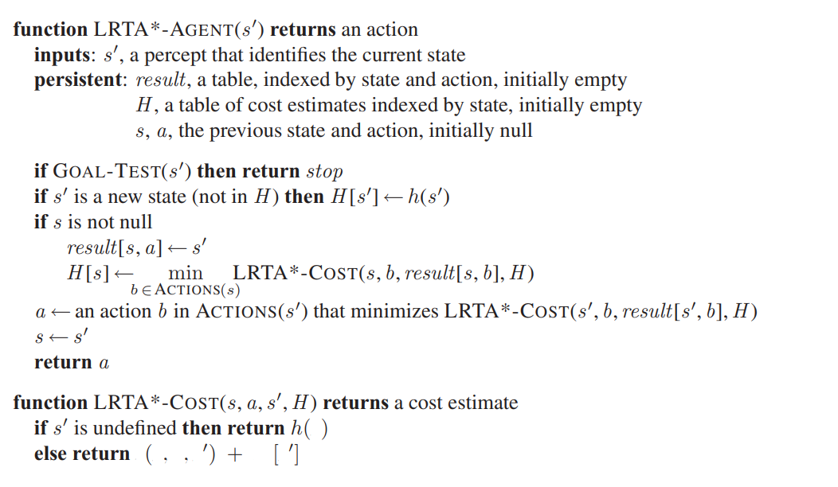

# CHAPTER 11: Constraint Satisfaction Problems

## 11.1. Definition

* A constraint satisfaction problem consists of three components, X, D, and C:

X is a set of variables, {X1,..., Xn}.

D is a set of domains, {D1,..., Dn}, one for each variable.

C is a set of constraints that specify allowable combinations of values.

* Example: Problem color each region

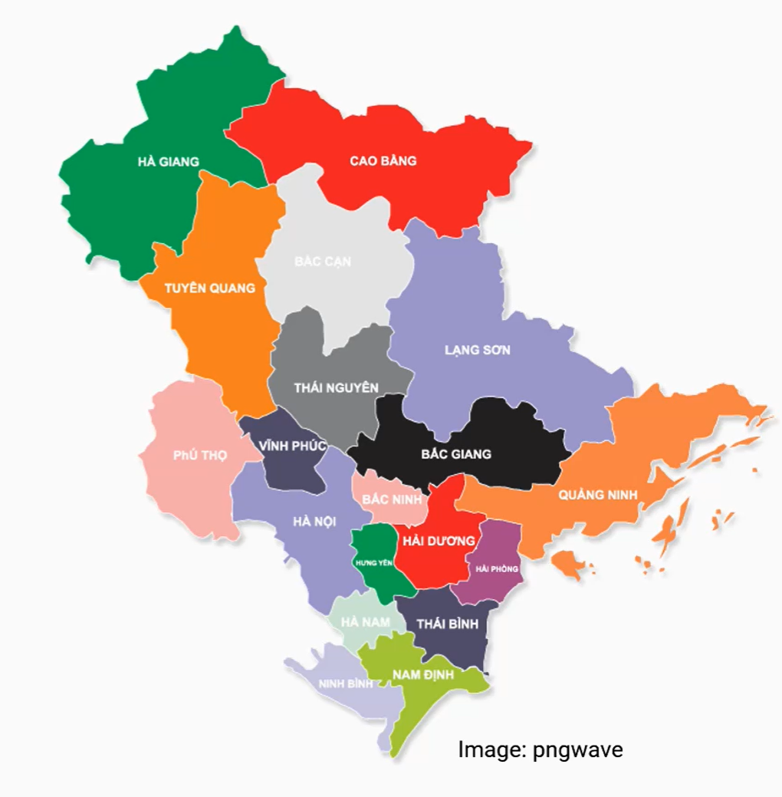

X = { Hà Giang, Cao Bằng, Tuyên Quang, Lạng Sơn, … }

D = { di = {Red, Green, Blue} for i $∈$ X }

C = { Hà Giang $≠$ Cao Bằng, Cao Bằng $≠$ Lạng Sơn, Hà Giang $≠$ Tuyên Quang, … }

## 11.2. Constraint Propagation: Inference in CSPs

* CSP can be solved by using searching on state-space search (DFS, BFS), but it will lose the advantage of the CSP solvers. Its advantage is to describe our state by using factors, when we look at the factors of the state it will help us quickly narrow the domain of variable

### 11.2.1. Constraint propagation

* In regular state-space search, an algorithm can do only one thing: search. In CSPs there is a choice: an algorithm can search or do a specific type of inference called constraint propagation: using the constraints to reduce the number of legal values for a variable, which in turn can reduce the legal values for another variable, and so on. For example:
  + When we already have a variable, and it is assigned a value then they use constraints between variables to narrow their domain. If domain of Hanoi changes, the domain of the provinces that border Hanoi will also change
* So, the CSP is solved when we propagate the constraints to all the variables until the domain of all variables is reduced to one.

### 11.2.2. Local Consistency

* The key to constraint propagation. Local consistency is the elimination of the variables that causes inconsistency. Types of local consistency:
* Constraint Graph:
* Node: variables
* Arc: if two variables are in any constraint, there will be a side connecting those two variables. For example Color region problem

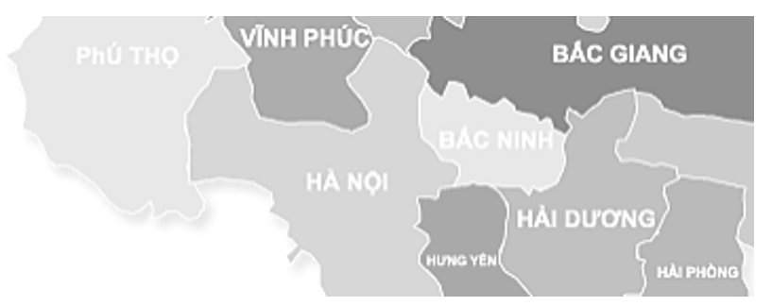

* Constraint graph:

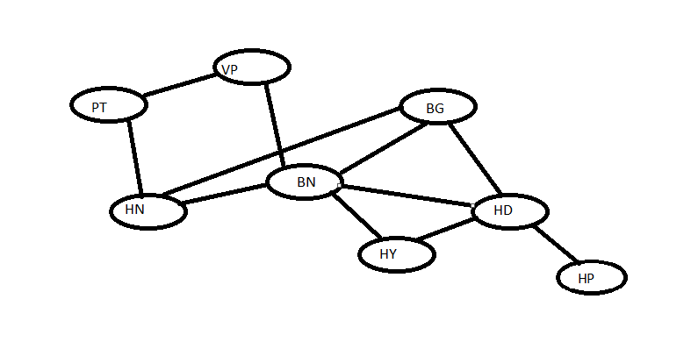

### 11.3. Node consistency

* A single variable (corresponding to a node in the CSP network) is node-consistent if all the values in the variable’s domain satisfy the variable’s unary constraints.
* For example: 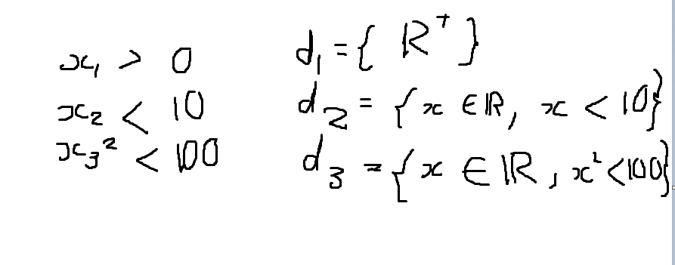

## 11.4. Arc consistency

* A variable in a CSP is arc-consistent if every value in its domain satisfies the variable’s binary constraints. Xi is arc-consistent with respect to Xj if $∀$ Xi di , Xj dj  : (Xi , Xj)
* For example: consider the constraint, Y = X2

Dx = {0,1,2,3,…,9}

Dy = {0,1,2,3,…,9}

=> this is not arc consistency

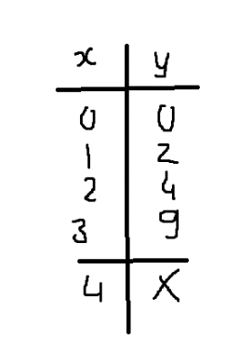

=> Dx = {0,1,2,3}

Dy = {0,2,4,9}

## 11.5. AC-3 Algorithm

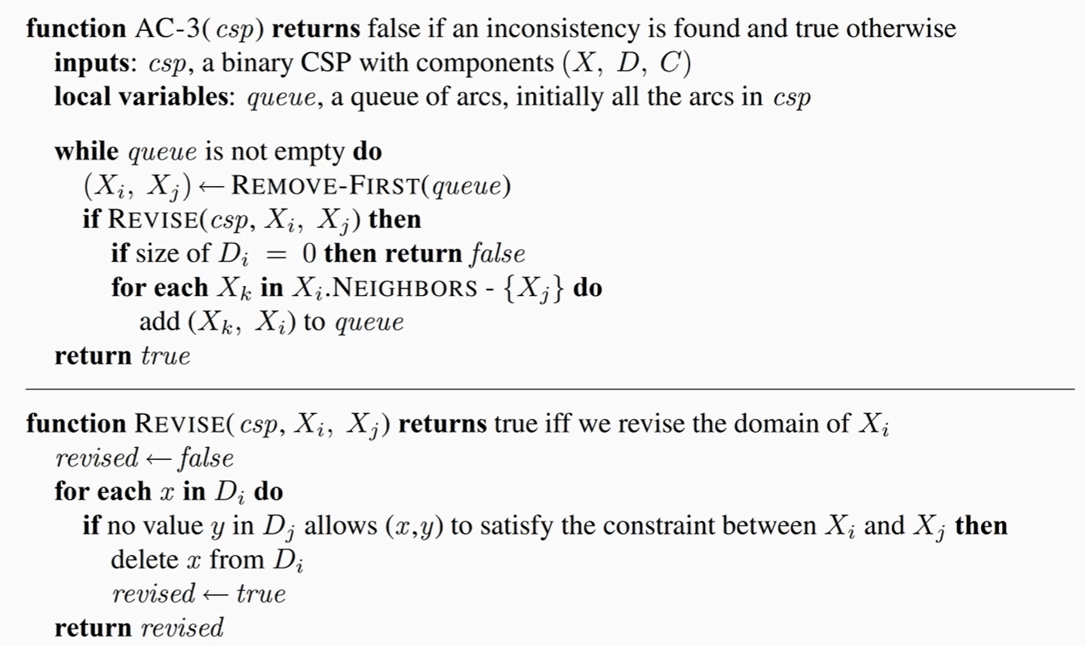

* Function Revise:
* Input: csp and pair of variables(Xi, Xj)
* Output: return true if the domain changes and false otherwise
* Loop: Get each variable x of Xi in Di (Domain)(descrete set)
* If no variable of Xj  that allow satisfying the constraint between Xi and Xj
* Delete x from Di
* Return revise = true
* Function AC-3:
* Input: csp, a binary CSP with components (X, D, C)
* Output: return false if an inconsistency is found and true otherwise
* Use Queue to contain arcs, initially all the arcs in CSP
* The loop will run until the queue is empty
* When the queue is not empty it will:
* Get the first pair of variables
* Check Revise of those pair of variable if revise is true that means domain of Xi is reduced
* Check Di size if Di size = 0, the problem has no solution
* else we use a loop for each var in the neighbor of Xi and add them into queue

## 11.6. Path Consistency

A two-variable set {Xi, Xj} is path-consistent with respect to a third variable Xm if, for every assignment {Xi = a, Xj = b} consistent with the constraints on {Xi, Xj}, there is an assignment to Xm that satisfies the constraints on {Xi, Xm} and {Xm, Xj}.

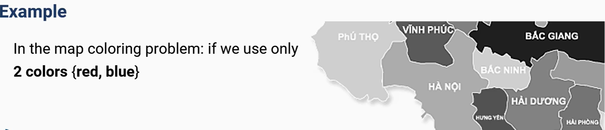

Consider: HN = red, BN = blue => BG = $∅$

=> we can't use 2 colors to color the map.

PC-2 Algorithm can enforce path consistency. It is very similar to the AC-3 algorithm.

### 11.7. K-consistency:

A CSP is k-consistent if, for any set of k − 1 variable and for any consistent assignment to those variables, a consistent value can always be assigned to any kth variable.

## 11.8. Global constraint:

* Global constraint is one involving an arbitrary number of variables (but not necessarily all variables).For example
* Alldiff constraint(HN, BN, BG): HN $≠$ BN, HN $≠$ BG, BN $≠$ BG
* Atmost constraint in the car assembly scheduling problem,

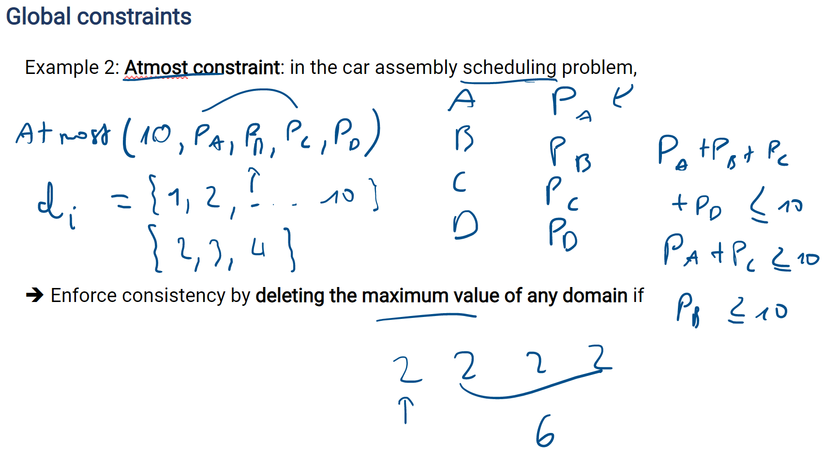

## 11.9. Sudoku problem:

No digit appears twice in any row, column, or 3x3 box.

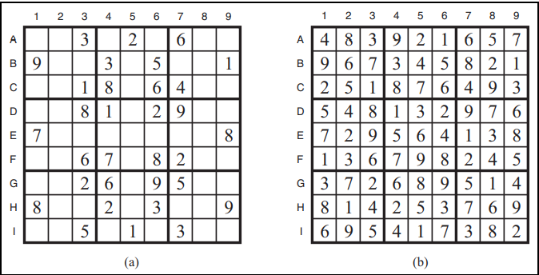

Variables: X = {A1, A2, A3,…}

Domains: D = {Di = {1,2,3,..,9}, DB1  = {9}, DA3 = {3} }

Constraints: Alldiff constraints: one for each row, column, and a box of 9 squares.

Alldiff (A1,A2,A3,A4,A5,A6, A7, A8, A9)

Alldiff (B1,B2,B3,B4,B5,B6,B7,B8,B9)

· · ·

Alldiff (A1,B1,C1,D1,E1,F1,G1,H1,I1)

Alldiff (A2,B2,C2,D2,E2,F2,G2,H2,I2)

· · ·

Alldiff (A1,A2,A3,B1,B2,B3,C1,C2,C3)

Alldiff (A4,A5,A6,B4,B5,B6,C4,C5,C6)

· · ·

**Solving Sudoku problem:**

1. Approach 1: AC-3 algorithm. Directly reducing domains of variables using the constraints
2. Approach 2: Triplets

* In a unit, find 3 squares
* Remove these 3 numbers from domains

The mentioned approaches can apply to any CSPs, not just Sudoku.

# CHAPTER 12: BACKTRACKING SEARCH FOR CSPS:

## 12.1. Ideas of backtracking search:

* A depth-first search that chooses values for one variable at a time and backtracks when a variable has no legal values left to assign. Main step:

1. Choose an unassigned variable

2. Assign one value

3. Repeat (1), (2) until

* Get solution: Empty domain -> backtrack
* Backtracking search algorithm: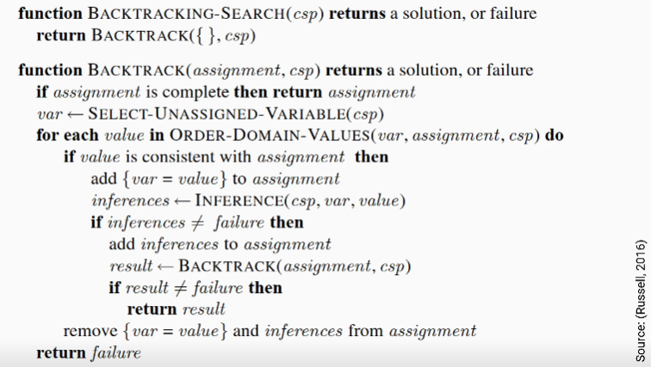

* Main function: backtracking-search

Input: 3 components X, D, C of CSP

Output: return a solution or FAILURE

* Function: backtrack

Input: assignment (variables have already assigned), CSP

If the assignment is complete, then return solution

Else select an unassigned variable from CSP and assign it to var

Loop: try values in domain

If the value is consistent with assignment, then

Add {var = value} to assignment

* When we add it to assignment, the domains of var are changed then the domains of a neighbor of var are also changed so we run inference function to reduce the domain and it helps to find faster.
  + - If inference return Failure (Domain = $∅$)
    - Else return variables their domains have only one value.
    - Call recursion backtrack until checking of result return solution or Failure. If it returns failure, it will rerun trying values in a domain or more so it will rerun selecting an unassigned variable from CSP and assign it to var
    - Else remove {var = value} and inference from assignment

## 12.2. Setting:

### 12.2.1. Select next variable and value

* For the selection of the next variable:
* Random selection
* Minimum remaining-values heuristic:
* Choose var that has minimum domain
* Degree heuristic:
* Degree means the number of constraints that the var is in it.
* For the selection of next value:
  + Random selection
  + Least-constraining-value heuristic:
* Choose value -> most choices for other variables

### 12.2.2. Inference:

* Propagation constraint to reduce domains of other variables when having a new assignment (var = value)
* Forward checking: Check if the domain of neighbors $≠ ∅$-> OK. Else stop and choose another one.
* Advantage: quick
* Disadvantage: not checking all
* Maintaining arc consistency: Check all variables
* Advantage: check all
* Disadvantage: slow

### 12.2.3. Backtrack strategies:

* Chronological backtracking:



[HN = b, BG = r, HY = g, VP = r, PT = g, HP = b]

-> BN = $∅$-> backtrack assign value again for HP and backtrack until OK

* Backjumping: store a conflict set – set of assignments conflicted with the value of current variable

# CHAPTER 13: CAL SEARCH FOR CSPS:

## 13.1. Ideas:

* Initial for every variable. Get 1 variable and change its value then try to reduce the number of constraints that causes conflicts.

**13.2. Min-conflict algorithm**: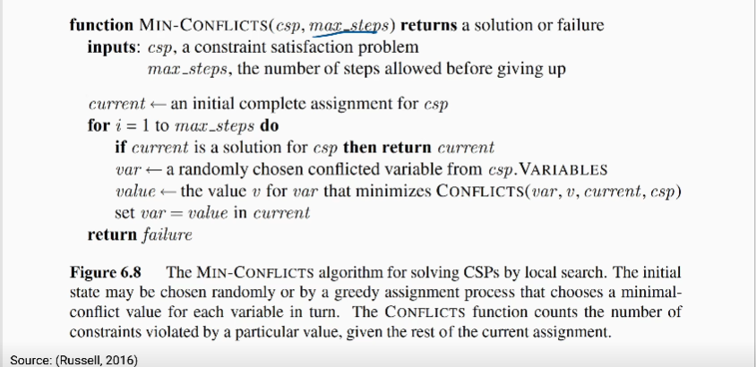

* Function min-confilct:
* Input: csp(X, D, C), max_steps
* Output: return solution or Failure
* Max_steps: maximum number of steps, it is not sure that it can find a solution among those steps. Value initialization
* Loop: If the current is a solution for CSP then stop and finish. Else randomly chosen conflicted variable, choose a value for this var that the value minimizes the number of constraints. Assign this value to a variable. For example: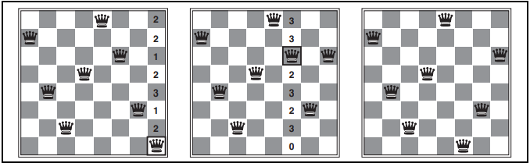
* A two-step solution using min-conflicts for an 8-queens problem. At each stage, a queen is chosen for reassignment in its column. The number of conflicts (in this case, the number of attacking queens) is shown in each square. The algorithm moves the queen to the min-conflicts square, breaking ties randomly.

Min-conflicts are surprisingly effective for many CSPs.

* It solves even the million-queens problem in an average of 50 steps (after the initial assignment).
* It has been used to schedule observations for the Hubble Space Telescope, reducing the time taken to schedule a week of observations from three weeks to around 10 minutes.

# Final Project

## 1. Introduction:

With the explosion of global information technology today, digital technologies have strongly developed. Smartphones with many different operating systems are increasingly trusted by users. Catching the trend of game programmers coming up with ideas and creating good and very attractive game applications and games that have gone into legend, everyone knows it. It's a programmer's success. In Vietnam, game programmers on operating systems have not developed strongly.

Through research and understanding of the group, I found that the Snake game is a classic and outstanding game. appeared in 1997 on the Nokia 6610 are consecutive squares moving on a simple screen, but the Snake has built its name very successfully. Therefore, our group decided to build a snake game program based on their ideas, using learned AI algorithms to apply. In the process of analysis and design due to limited time and qualifications, the program cannot avoid shortcomings. So we are looking forward to your advice.

## 2. Analysis:

### 2.1. Algorithm:

* Our group uses the Breadth First Search (BFS) algorithm to apply it to find the shortest path from the snake's location to the apple's location.

### 2.2. Code:

#### 2.2.1. Libraries:

* Pygame: is a set of cross-platform Python modules designed for writing video games that includes computer graphics and a sound library..
* Random: library with random algorithm.

#### 2.2.2. Setting:

* Setting.py

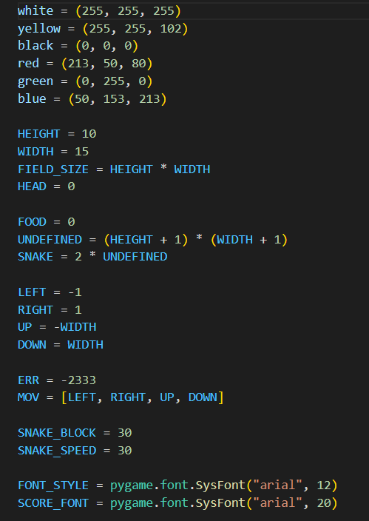

#### 2.2.3. Function:

* Initialize the environment

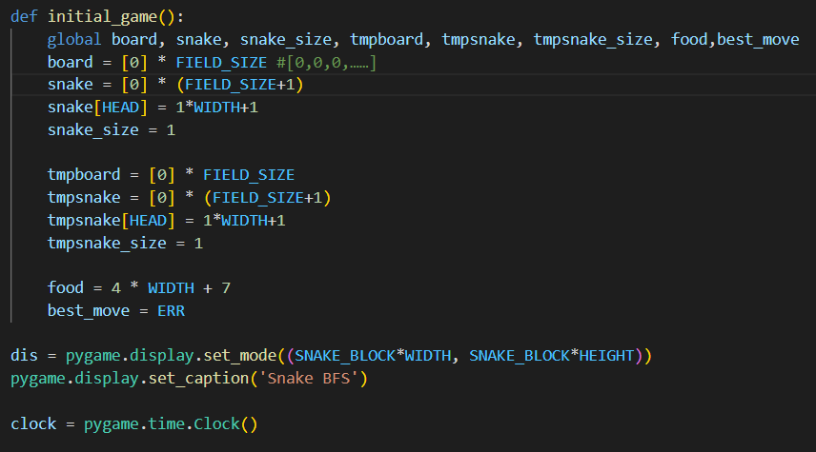

* Show Score:

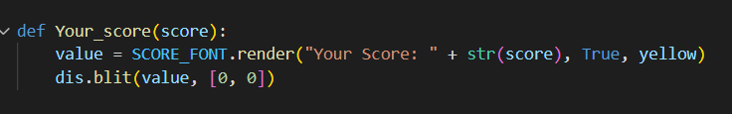

* Draw the snack( head, body and tail) and apples:

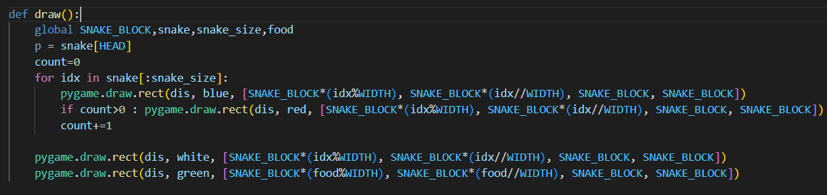

* Show Notifications:

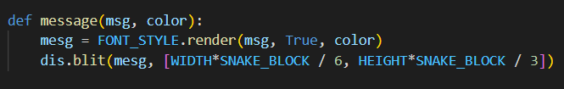

* Initialize apples:

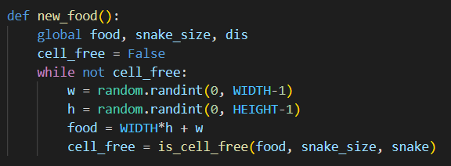

* The directions of the snake:

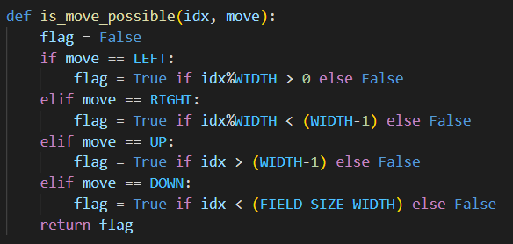

* Available cell check function::

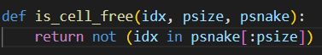

* Breadth First Search (BFS) algorithm: find the shortest path from the snake to the apples.

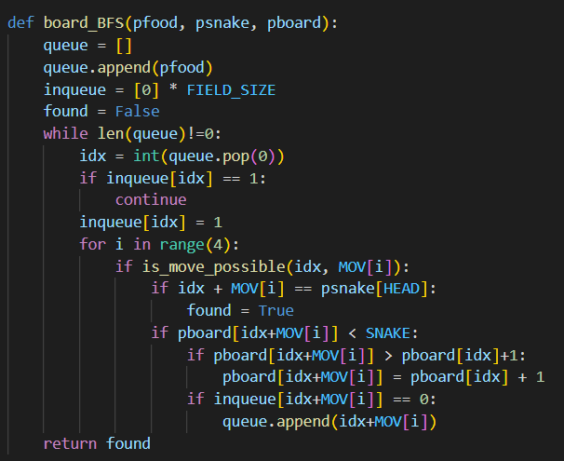

* “virtual_shortest_move” function to bring the snake to the food location found by BFS. At that position, we check if there exists a path from the snake's head to its tail.

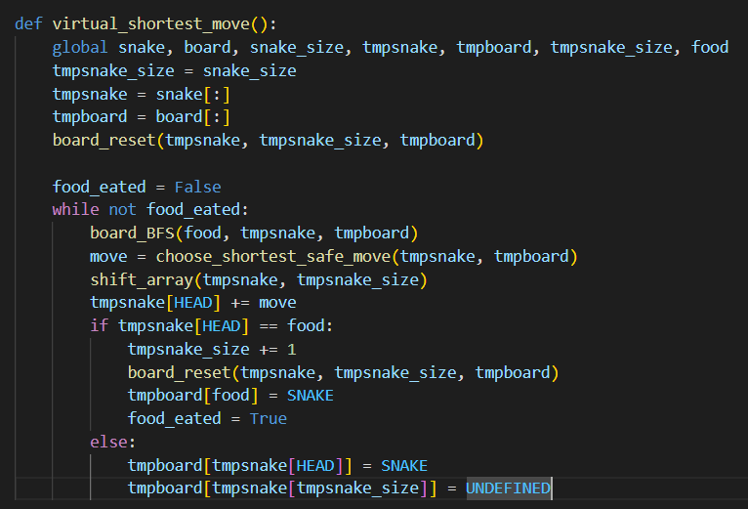

* The function checks the tail so that the snake can chase its tail, we use the trick of converting the state of the food cell to the state of the box containing the snake's tail and traverse the BFS. After swapping, BFS will find the shortest path to the tail's location without traversing the food cell.

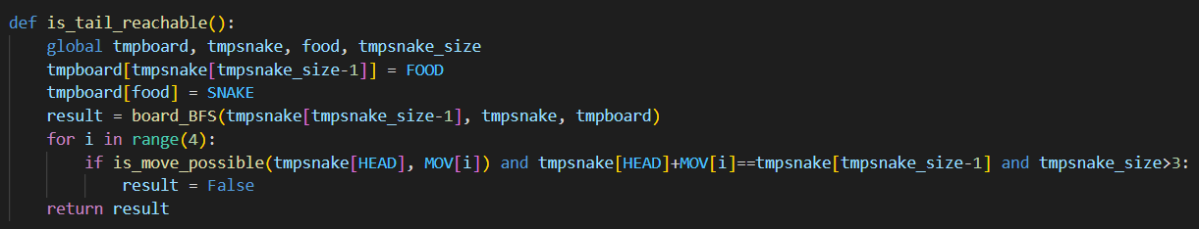

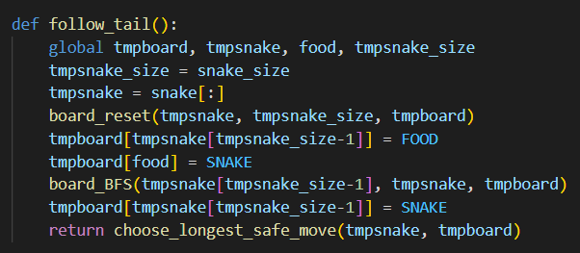

* The snake's jaws move and check if the snake has eaten the apple then increase in size and create new food.

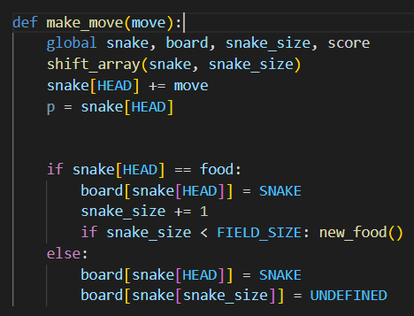

* The function checks whether the cell is an apple or a snake or is empty.

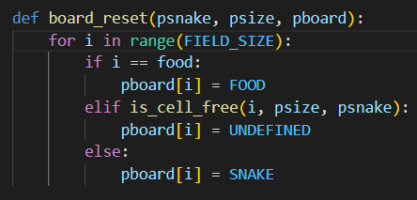

* Find a safe route:

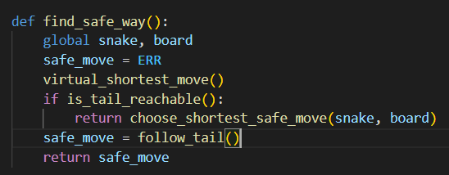

* Based on the result of BFS, we can find the shortest and longest path. When the snake chases food, it needs the shortest path, when it chases its own tail, it should choose the longest path (among the shortest paths) to have more space to stay. game longer..

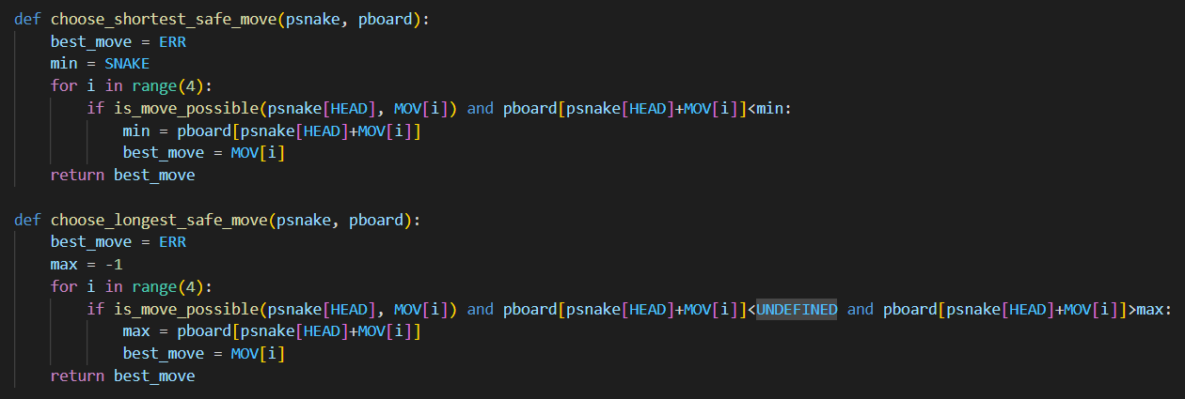

* “GameLoop()” function: Loop for the snake to keep moving and eating apples until the game over

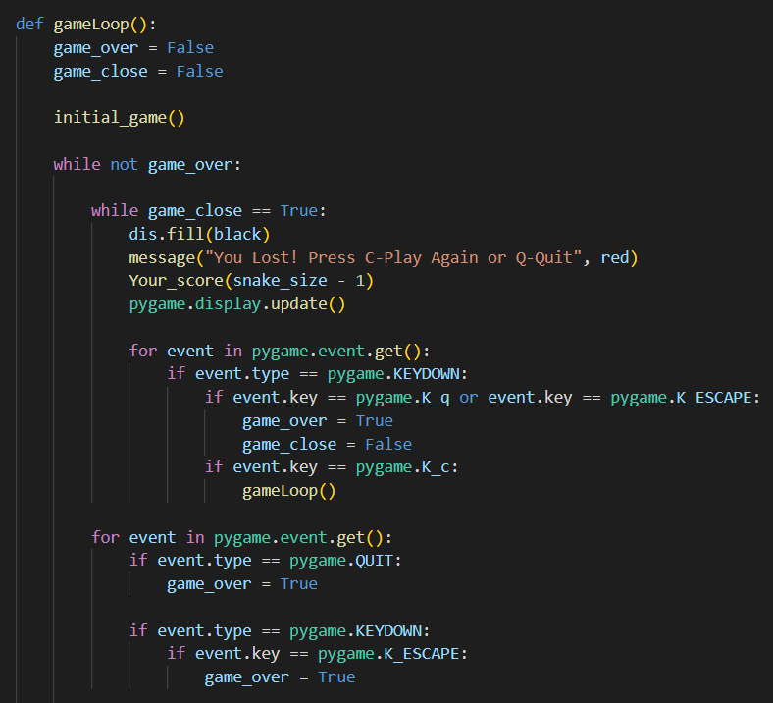

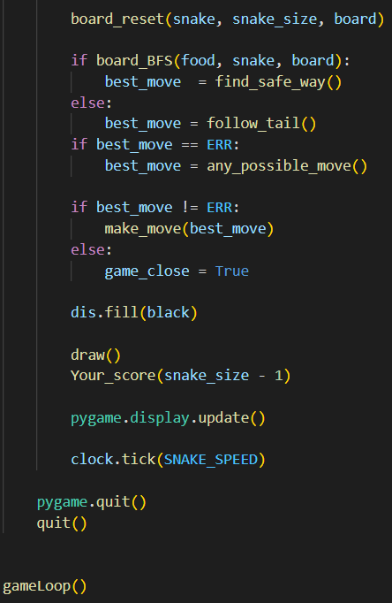

# REFERENCES

[1] Ph.D. Tran Nhat Quang (2022). *Lectures on Artificial Intelligence*

[2] Stuart J. Russell, P. N. (2016). *Artificial Intelligence A Modern Approach*. EdinburghGate Harlow Essex England: Pearson Education © 2010.

[3] *Artificial Intelligence* (n.d.). Wikipedia, the free encyclopedia. Retrieve 10/12/2022 from <https://wikipedia.org/wiki/Artificial_intelligence>

[4] *Wang Jiaer studies Python.* (2022). Python realizes automatic snake playing program. Retrieve 10/12/2022 from <https://pythonmana.com/2022/03/202203250321058778.html>